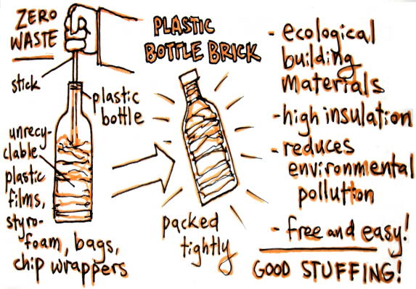 | Bellingham Middle School  PHSE Enrichment Task  Whole School Opportunity | EcoBricks  Our oceans are suffocating under the pollution of our actions. As a global community, we have failed to look after the oceans that surround us and all the creatures and organisms that inhabit them. We are running out of time. We need to make a change in the way that we use and reuse plastic, before it is too late.  The time to act is now – our oceans need us to act fast.  Do something great – make a change!
“Everyone can make little changes, and together those little changes, make one great big change.”  Blue Planet Conservationist  A recent 10 year Challenge  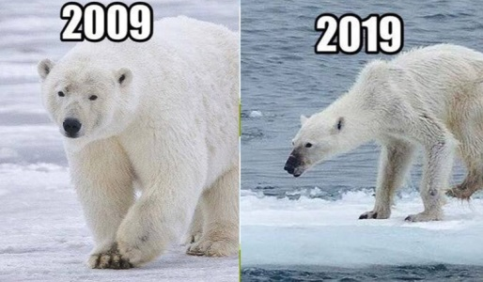  Top tip!  Cut your plastic up into little pieces before packing it into your bottle – it helps to firstly to get as much plastic as possible into the bottle, and secondly, it helps to distribute the weight evenly throughout the bottle.  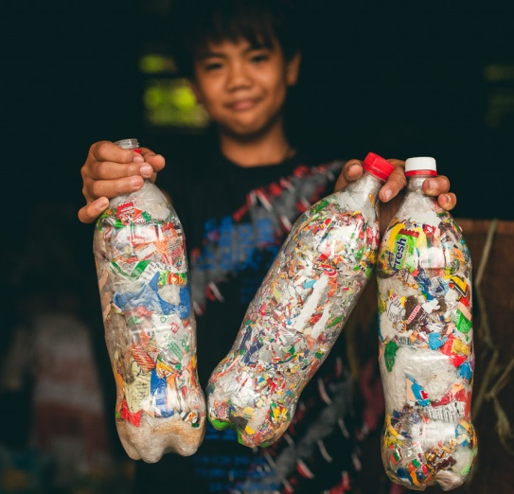 |  | Before beginning the task  Watch the video from Blue Planet  https://www.bing.com/videos/search?q=blue+planet+plastic+in+oceans+clip&view=detail&mid=18D4F6DC16978C58FB3518D4F6DC16978C58FB35&FORM=VIRE  Watch the video – Ecobricks a solution to pollution  https://www.ecobricks.org/what/  MAke a change – Build your Ecobrick  Follow the instructions within the following video:  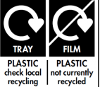  https://www.ecobricks.org/how/  You will need:  - A plastic bottle  - A stick  - A large quantity of plastics (non-recyclable – usually found as food packaging around fruit and veg, cellophane, and Styrofoam. Check the labelling of packaging.  You will need a photograph of your Ecobrick for your enrichment book, and you should also bring your completed brick into school so that it can be used as part of a school building project.  WRITTEN TASK  KS2:  Write a set of instructions that explain to others how to make an Ecobrick. Your instructions should include diagrams or photographs.  KS3:  Write a short essay that discusses the current dangers that our oceans are facing.  LEARNING OBJECTIVE AND SUCCESS CRITERIA  L/O: I can contribute to my global community.  Success Criteria:  I can collect and reuse non-recyclable plastics to create an Ecobrick.  I can photograph my finished Ecobrick for my enrichment book.  I can complete my written task in my neatest handwriting (or accurately word process it) and include it in my enrichment book.

