Y8 Science Enrichment Homework 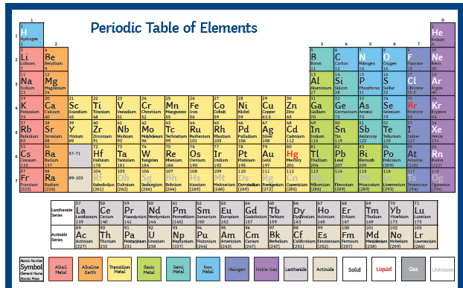

Periodic Table Game
Understanding the Periodic Table is really important for doing well in Chemistry GCSE. This enrichment homework will improve your understanding of the elements, patterns and trends in the Table and may allow you to challenge your friends.
Your task is to develop a game based on the Periodic Table. This could be a board game, card game or quiz game.

A prize will be given to the best entry from Y8.

Consider:
• How the elements are arranged in vertical Groups and horizontal Periods.
• The trends in atomic number and reactivity up or down the Groups.
• The symbols, chemistry and economic importance of different elements.
• Where different types elements are found such as metals, semi-metals and non-metals.
• Including a set of instructions for how to play (and win) the game.

Challenge: Within the game try to include questions or facts on electronic configuration (e.g., Group 1 metals such as sodium have one electron in the outer shell).

This homework should take you at least two hours and should be well presented; use appropriate scientific language, symbols and check your SPAG.
Remember to take photos and evaluate your work in your Enrichment Homework book.

