HEADTEACHER MESSAGE

What a fantastic final week of term we have had at Bellingham Middle School! The huge cast of “The Amazing Adventures of Super Stan” delighted a packed hall on Tuesday evening, with a story that reminded us all about believing in ourselves and that the support of our friends and family will always be with us, no matter what. Congratulations to everyone for this special night.

Following a wonderful superhero themed prom last night, our lovely Y8 pupils leave us today. We will miss them enormously but send with them off with our best wishes for every happiness and success as they move on to high school.

Finally, we bid farewell to Miss Anderson, Mrs Gandham, Ms Taberham and Mrs Baxter, all of whom begin new adventures next term. We thank them for their contribution to Bellingham Middle School and know that they will be much missed. From September, highly experienced specialist design technology teacher and professional artist, Mrs Basing will join the staff whilst English specialist and GCSE English Literature examiner, Mrs Stutchbury, will deliver our exciting and challenging Y8 English programme.

Thank you for all your support this year. Happy holidays!

Kind regards,
Helen Samuels,
Acting Headteacher
______________________________________________________________________________________

LOOKING FOR SOMETHING TO DO TOGETHER THIS WEEKEND?

COMMUNITY NEWS AND EVENTS

Sat 21st & Sun 22nd July - Allenheads Contemporary Art: BEYOND - an incredible line up of extraordinary exhibitions and experiences all jammed into one weekend, inspired by the project BEYOND and the use of the North Pennines Observatory @ACA With a range of daytime and evening and free events this weekend, including BEYOND exhibitions, midnight stargazing sessions, flotation tanks, cosmic pond underwater soundscape and a finale BBQ, it's set to be a great weekend. Venue: ACA, Old School House, Allenheads. NE47 9HR From Sat 2pm until Sun 6pm.

Sat 21st July - 50th Anniversary of the Northern Poetry Library: (FREE) based at The Chantry building in Morpeth, the library has come together with local performing arts company November Club to celebrate its 50th birthday. Festivities include The Remarkable Dr McCavity and his Travelling Surgery on the streets of Morpeth with his glamorous assistant Ginger Vitis, dispensing very special prescriptions in rhyme. 10am – 4pm. All welcome.

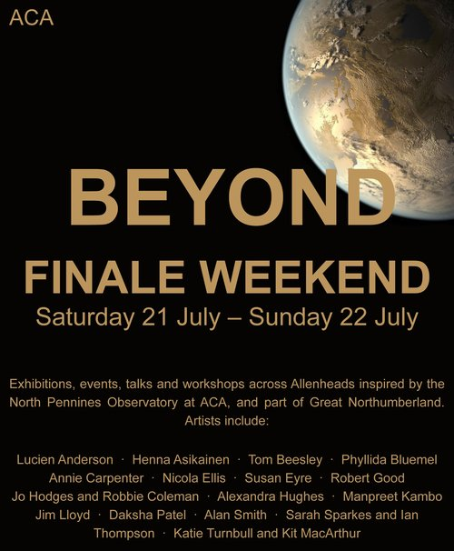

30th June – 9th September 2018: Get North Water Sculpture. (FREE) Be wowed by the UK’s largest water sculpture which will perform hourly. Download three specially commissioned soundtracks and experience this impressive spectacle to three different pieces of music. The Water Sculpture is 80m long and reaches the height of the Tyne Bridge. Open daily between 10am and 11pm.


Attendance this week – 89.4%


Thank you! We really appreciate all your efforts in getting to school on time, ready to start our day promptly.

Please remember holidays in term time will be unauthorised.

Congratulations to Emily (5R) and Noah (5R) for 100% attendance this year!
_______________________________________________________________________________

SCHOOL NEWS AND EVENTS

HOUSE RESULTS 2018

KESTREL (5439) | MERLIN (5249) | OSPREY (4613) | PEREGRINE (5687)
Individual Headteacher’s Awards

Hannah (5A), Emily (5A), Arthur (5A), Katie (5R), Jenny (5R), David (Y6), Amy (Y6), Samantha (Y7)

Each of these pupils earned a staggering 300+ housepoints. Well done!

CONGRATULATIONS TO PEREGRINE – this house won overall for both the
HOUSE POINTS CUP & THE HOUSE SPORTS CUP. What an amazing achievement!


BMS London Trip 2019: We are delighted to be able to let you know that our exciting London trip is going ahead. Make sure you check your child’s bag for their letter of confirmation and payment schedule. First instalment is due on 7th September.

Y8 Leavers’ Trip: Lucky Y8 pupils enjoyed a chance to go on one final school trip together to South Shields Beach. They were fortunate with the weather and, as ever, this super year group were a credit to themselves and to their school. Thank you to Miss Mason, Mrs Ingledew and Mrs Batey for accompanying the pupils as they spent time together on this special day.




Y6 Grow £5: Enterprising Y6 pupils’ business plans came to fruition this week as it was announced that the pupils have raised £217 in total. The most profitable company was “The Real Deal”, who grew £82 from the original £5 start-up funding. After enjoying the fruits of their labours with a delicious celebration lunch, Y6 decided to split their profits between Cancer Research and The Donkey Sanctuary, adopting a foal called Simon at The Scottish Borders Donkey Sanctuary, St Boswell, TD6 OEL. This adorable baby animal would love a visit if any families wish to visit over the summer holidays together.

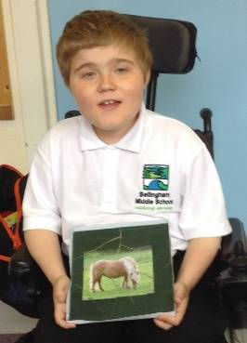
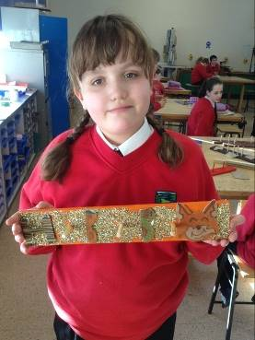
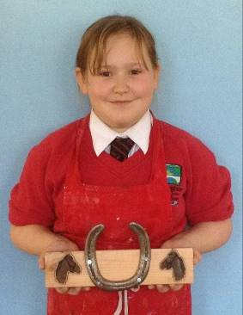
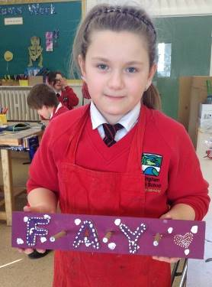
CREATIVE ZONE

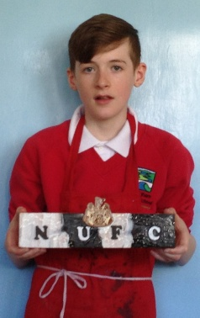
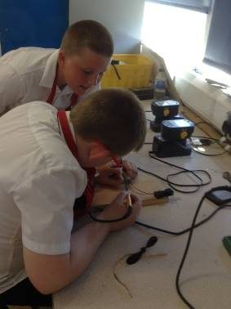
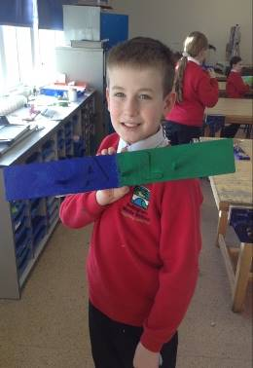
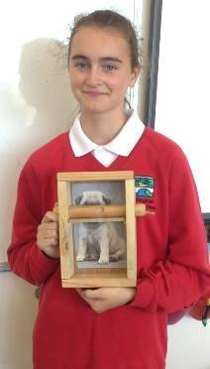

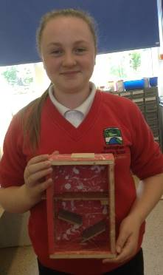
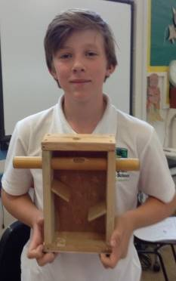
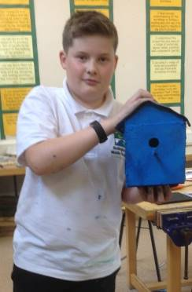
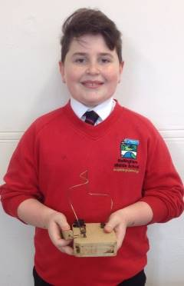

In years 5 and 6 this year, pupils have used lots of tools and machines to make a peg rail and a block puzzle. They chose and developed the design and colours for themselves. In year 7, pupils have made a sweet dispenser. This wasn’t an easy project because they had to make a lot of decisions for themselves in the workshop but look at the great results they have achieved. In year 8, two projects have been completed. The first was a bird house or feeder of pupils’ own design and the second was a ‘steady hand game’, learning about electronics and making their own circuit to fit into the game.
In year 8 we have completed two projects. Our first was a bird house or feeder of our own design and the second was a ‘steady hand game’ learning about electronics and making our own circuit to fit into the game.
In year 7 we have made a sweet dispenser. This wasn’t an easy project because we had to make a lot of decisions for ourselves in the workshop but look at the great results we have achieved!
Farewell message from Ms Anderson: “It has been an absolute privilege to work with such lovely children and staff. Thank you.”

MEMOS AND REMINDERS

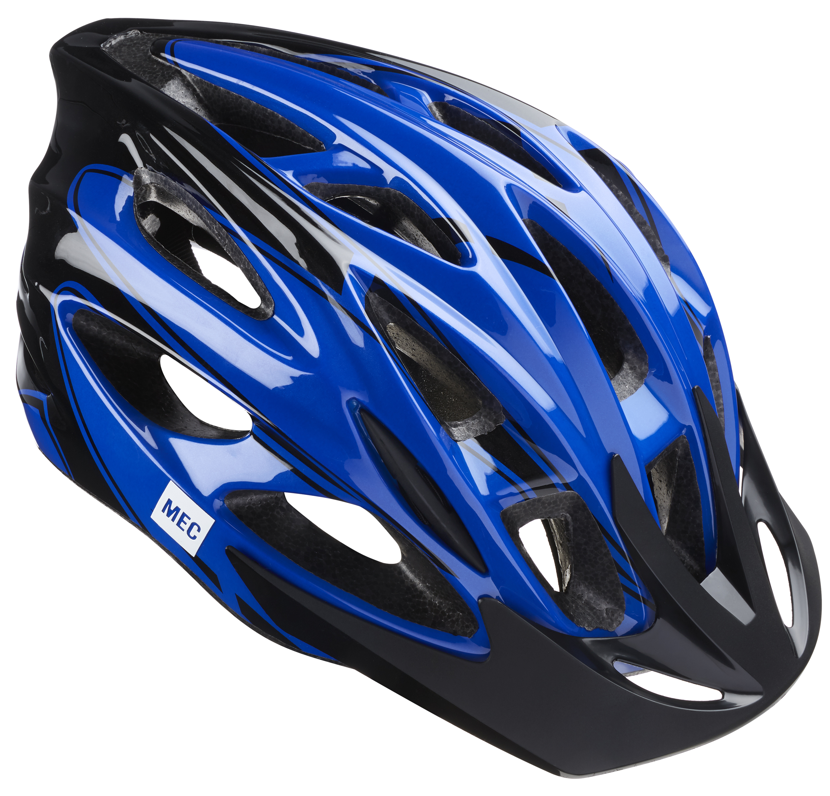 Bike Helmets: Your child must wear a bike helmet as he or she cycles to or from our school. We will let you know if we notice your child without a helmet and have to insist that he or she does not ride until one is worn. Please remind your child to stay safe on our roads by wearing a helmet. Further Bikeability training will be available next term.

Contacting school if your child is ill: Could all parents please inform us by 9.15 am if your child is not able to attend school due to illness. You can leave a message on the answerphone if the line is busy or email: middleadmin@bellinghampartnership.uk

Dinner Money: Please pay on the day or weekly from September. It is not possible to put credit on a tab. Whilst we would never see a child go hungry, we cannot afford to subsidise your child’s meal. If you would require free school meals for your child, please apply to Northumberland County Council, please call: 01670 623592 or apply online, using the link below. Thank you for your support.
https://online.northumberland.gov.uk/citizenportal/form.aspx?form=Free_School_Meals
:
FORTHCOMING EVENTS AND KEY DATES

Friday 20th July 11 am Celebration Assembly – all welcome
Friday 20th July End of Term
Mon 3rd Sept Teacher Training Day – no pupils
Tues 4th Sept Pupils return to school
Mon 7th Sept 1st instalment for London trip – pay by today
Fri 26th Oct Pupils attend school for last day of autumn first half term
Mon 5th Nov Teacher Training Day – no pupils
Tues 6th Nov Start of autumn second half term begins
Fri 21st Dec End of autumn term

