Year 8 Geography Enrichment Task – Spring 2
China Region Research
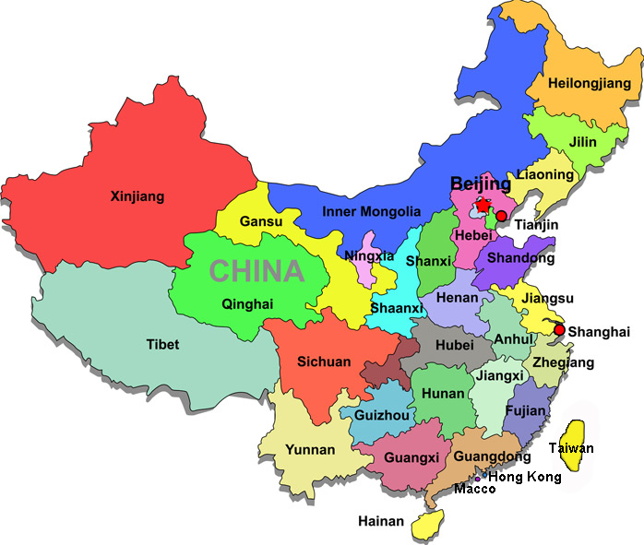
China is divided into 23 provinces. Your task is to select and research one of these provinces. You should include information on its capital, land area, population and population density.
Other ideas on what to include:
- History and traditions
- Physical and human features
- Main industries/employment
- Traditional regional foods eaten
- Other interesting or unusual facts
The presentation can be hand written or completed using ICT, but must be put in your own words and in your enrichment books. There should also be an evaluation of at least 100 words on how you found completing this task. It could include, for example, discussing any facts that you found surprising.
Due date:

