YEAR 8 HISTORY HOMEWORK – SPRING 1

Learning Objectives:
- To research and present information on six modern day countries which were ruled over by the British Empire.
Task:
You need to research six modern day countries that were ruled over by the British Empire (not including India or Australia).
You need to produce an information leaflet that contains the following:
- When the country gained independence from Britain.
- The key reasons why Britain ruled over it, e.g. main resources/location etc.
- Why Britain allowed the country to have its independence.

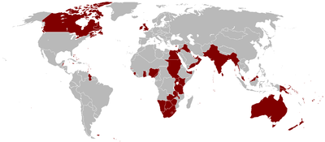

Deadline:
