Y5 Autumn 2 Science Homework.
The Solar System
Your task this term is to make a 3D model of the Solar System.
You may use any materials you wish.
Last year pupils used papier-mâché, lego, stones, polystyrene, Christmas baubles, clay, pompoms or a mixture of materials.
Success criteria:-
It must be your own work
You must explain and evaluate your work in your enrichment homework book along with a photograph (we can do this in school) as evidence.
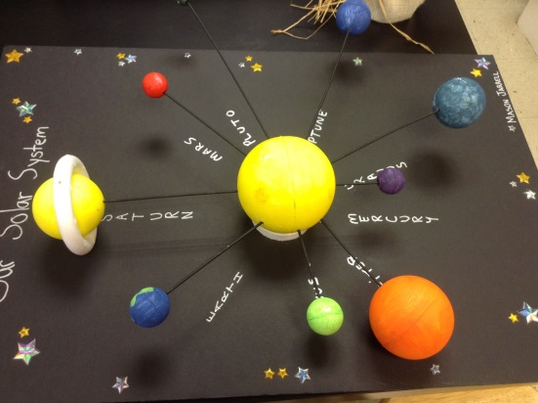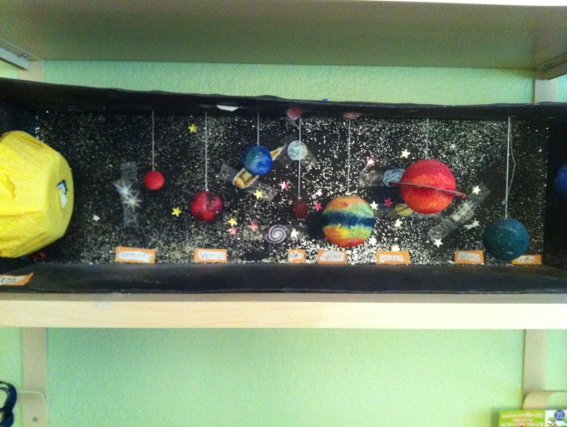
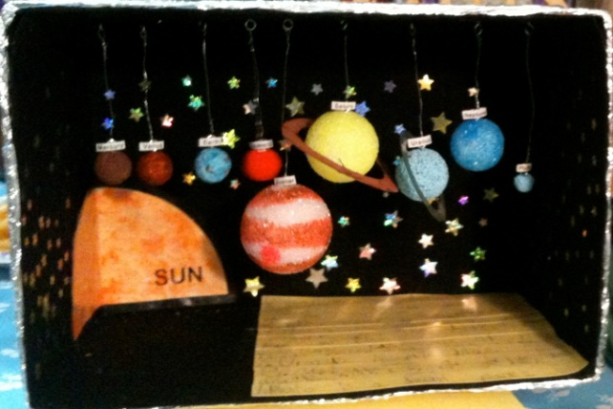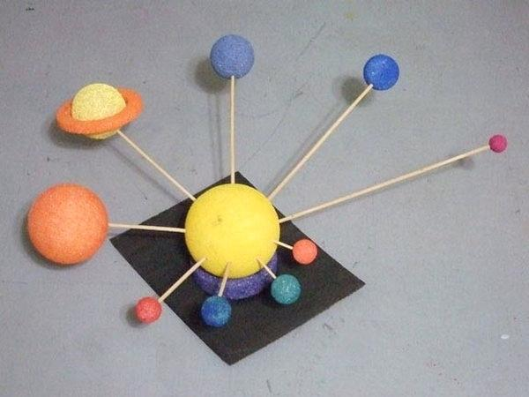
Have a look in the top corridor for more ideas.

