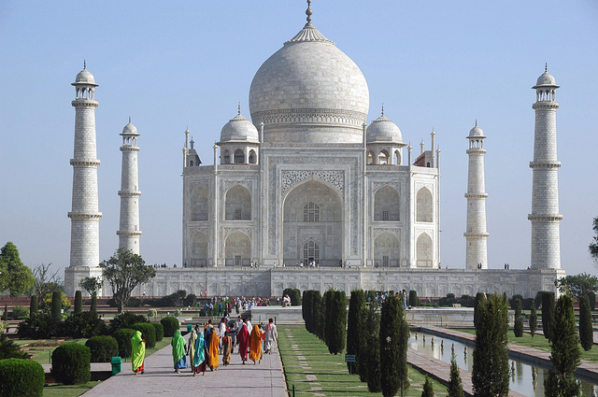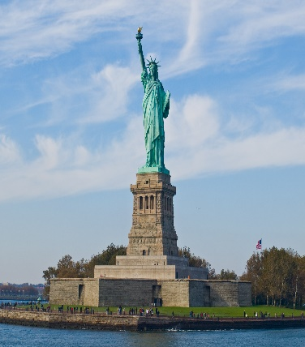
Autumn 2 Year 5 and 6 Modern Foreign Languages Enrichment Homework

Task one Choose one word in English. Find out what this word is in ten different languages across the world.
Task two Choose any country in the world that you are interested in visiting and write a paragraph to describe why you would like to visit this country. For each thing you describe you must give one reason why you would like to visit this place, taste this food, see this festival etc.

Success Criteria
- The capital city and one thing in this city that you would like to visit.
- One of the traditional foods that you would like to taste.
- One geographical feature that you would like to see eg a mountain or a sea; one historical place or monument.
- The traditional costume of this country.
- One cultural activity that you would like to watch or take part in, eg a dance, a sport, music, a celebration or festival.

You may illustrate your work with some nice pictures of some of the things that you describe in your paragraph.

