HEADTEACHER MESSAGE

Thank you to all those who continue to support our lovely school. It has been fantastic to have so many positive conversations with families, who clearly care a great deal about having a local middle school for their children. If you haven’t done so already, please remember to make your voice heard by sending a letter to: ​The Executive​ ​Director of Children’s Services, County Hall, Morpeth, Northumberland NE61 2EF. If you prefer, then you could also email your response to Educationconsultation@northumberland.gov.uk. The deadline is midnight on 7th June 2018.

It would be impossible let this week pass without congratulating our Y6 pupils, who worked tirelessly to complete their SATs this week. What a brilliant bunch they are! We would also like to thank all the parents and carers of these children for supporting them in what is always a challenging year. Finally, a special mention and thank you must go to Miss Mason and her support team for excellent SATs preparation and coordination, including a wonderful post-SATs party day for the children.

Kind regards,
Helen Samuels,
Acting Headteacher
______________________________________________________________________________________

LOOKING FOR SOMETHING TO DO TOGETHER THIS WEEKEND?

COMMUNITY NEWS AND EVENTS
 19th May 2018 - ‘Rainhill Trials’ at The Discovery Museum, Newcastle: Have a go at constructing the fastest LEGO® engine, or rocket car that travels the furthest. Could you be crowned the ultimate champion on the night? As part of The Late Shows 2018, stop off at the Discovery Museum and put your inventive creations to the test. Ahead of the return to Newcastle of Robert Stephenson’s iconic steam locomotive Rocket (on loan to the Discovery Museum from June 2018), Discovery Museum will be open after hours for their own version of the Rainhill Trials, at which you can test the speed and endurance of your creations across the Great Hall. 7pm – 11pm
 19th May 2018 - Royal Wedding Celebration Party @ Sanderson Arcade, Morpeth: To commemorate the marriage of Prince Harry and Meghan Markle - the Arcade will be holding a special event including all stores with a celebration tea party, live stream of the wedding, stilt walkers and much more! All welcome. 12pm – 5pm

 19th and 20th May 2018 – Haltwhistle Plant Festival: An annual specialist nurseries plant festival, which is a very popular event for all keen gardeners. Also included are a wide range of attractive craft stalls and a pop-up cafe serving locally sourced and Fairtrade food all day. Haltwhistle Swimming and Leisure Centre between 9:30am to 3:30pm

Attendance this week – 94.4%


Thank you! We really appreciate all your efforts in getting to school on time, ready to start our day promptly.

Did you know?

90% of young people with absence rates below 85% fail to achieve five or more good grades of GCSE and around one third achieve no GCSEs at all.
Below 90% = a persistent absentee (according to the government).

Schools have to send you a letter if your child’s attendance drops below 90%.
_______________________________________________________________________________

SCHOOL NEWS AND EVENTS

WELL DONE TO OUR HOUSE POINT HEROES OF THE WEEK!

KESTREL (119) | MERLIN (176) | OSPREY (157) | PEREGRINE (200)
Anna (5A)  Katie (5R)  Imogen (Y6)  Alex (Y7)  Josh (Y8) | Hannah (5A)  Lily (5R)  Daniel (Y6)  James (Y7)  Lucy F & Izzy (Y8) | Isla (5A)  Max (5R)  Georgia & Shaun (Y6)  Jack (Y7)  Fletcher (Y8) | Emily (5A)  Jenny (5R)  Lucy (Y6)  Callum (Y7)  Arran W (Y8)
Non-uniform reward day from last half term will be Kestrel & Peregrine on Tuesday 22nd May 2018.

Charity News
Neurofibromatosis Awareness Day
Today, it was a pleasure to see so many pupils making such an excellent effort to support the Childhood Tumour Trust by wearing blue and green. After a special assembly, everyone felt much more aware of NF1, and could definitely say Neurofibromatosis properly! A special thank you to Bethany and her family for helping us to understand better.

CLASS ZONE



ParentMail We hope that you have been enjoying our new BMS Bulletin each week. This copy will be the last hard copy sent home as we wish to encourage all families to use ParentMail. Please save the trees and sign up if you haven’t already. If you still need a hard copy sent to you, perhaps because internet access is an issue, please do let us know. Bulletins are also always posted on the school website.


Class Zone:
In Humanities this week, Y5 have been making the most of the glorious sunshine with outside lessons. Pupils have been learning about rivers and their various features. To showcase their learning, the pupils produced their own excellent chalk diagrams on the yard. The levels of detail were outstanding.
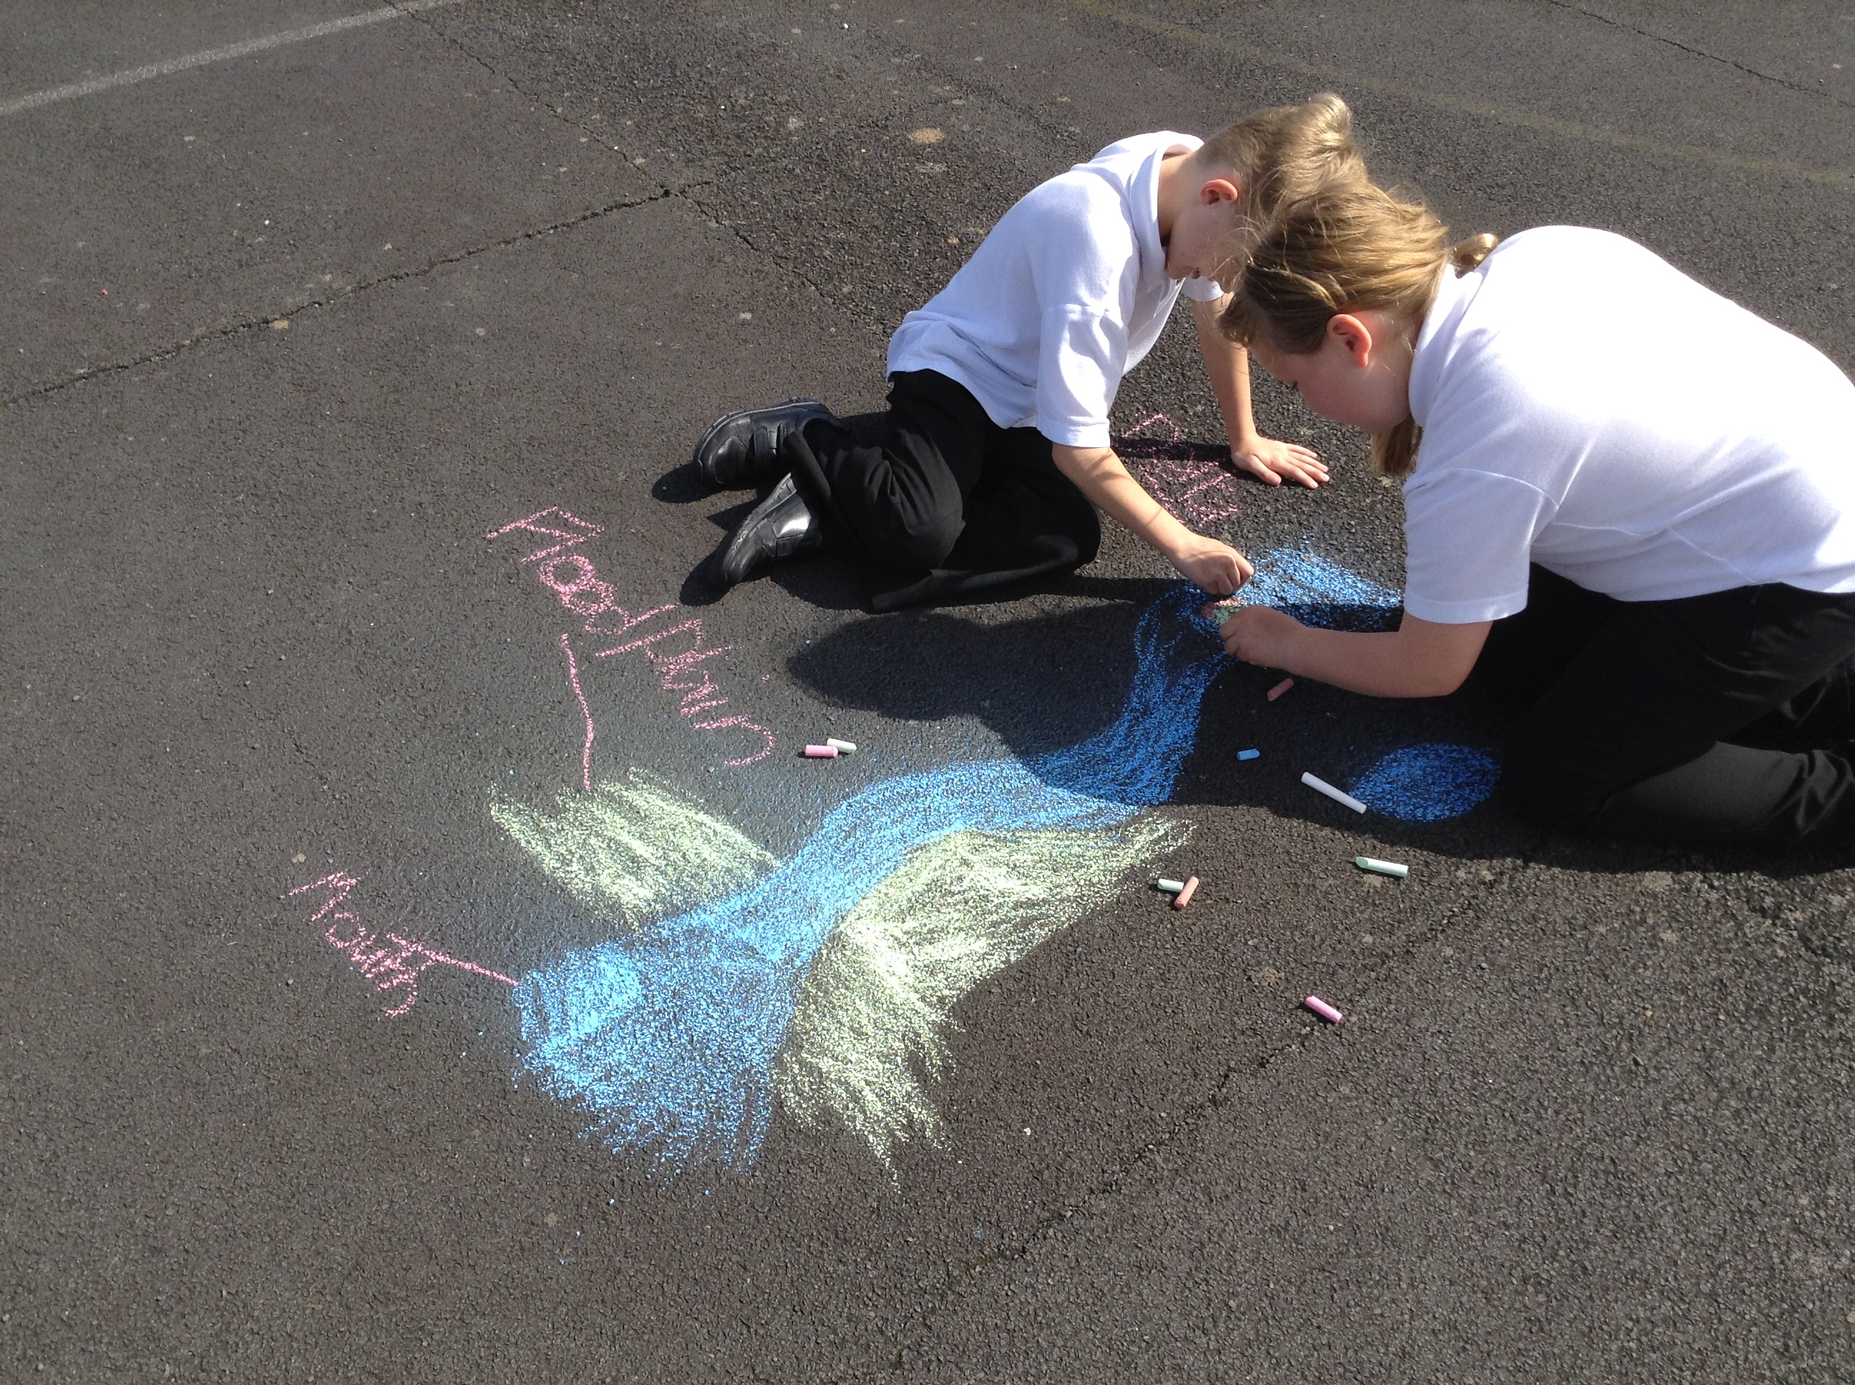
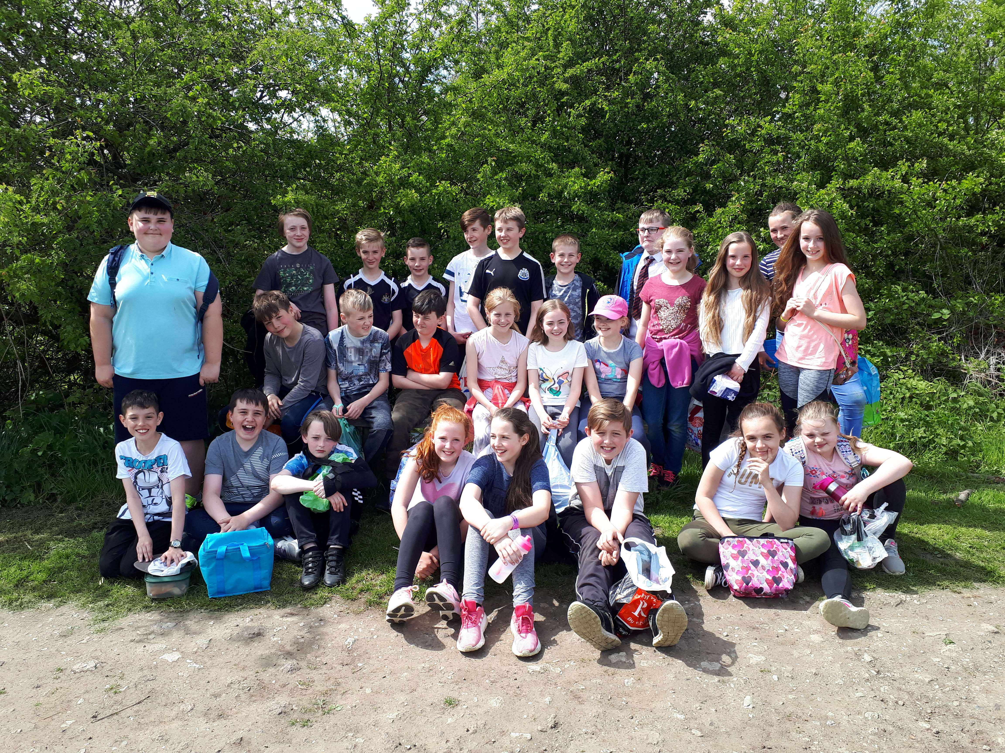
As soon as Y6 had finished their last SATs paper this week, they headed off for a hike up Hareshaw Linn and a delicious picnic. It was lovely to see them heading off, finally able to relax and enjoy themselves together.
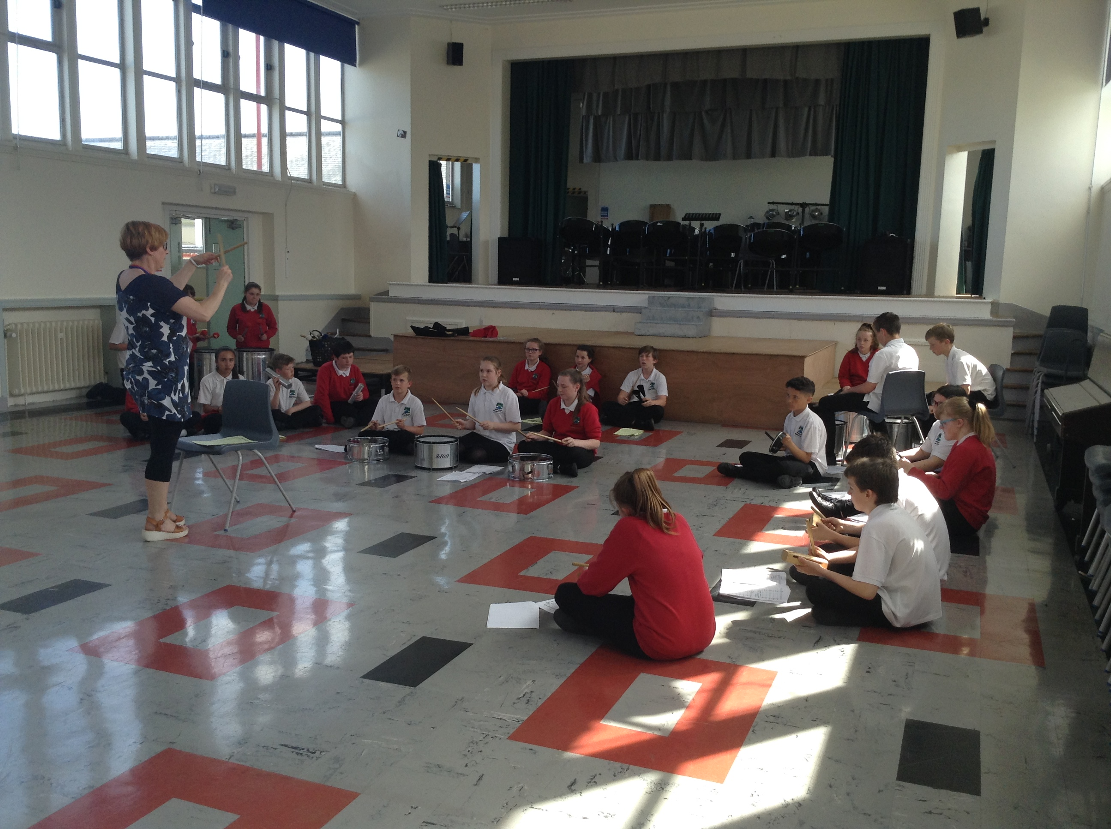
Vibrant sounds of samba echoed around school this week as rehearsals in Y7 music got underway. With Ms Wilson conducting, the whole class was able to find its groove, and combine the different layers of “Curry House Samba” on our authentic samba instruments.
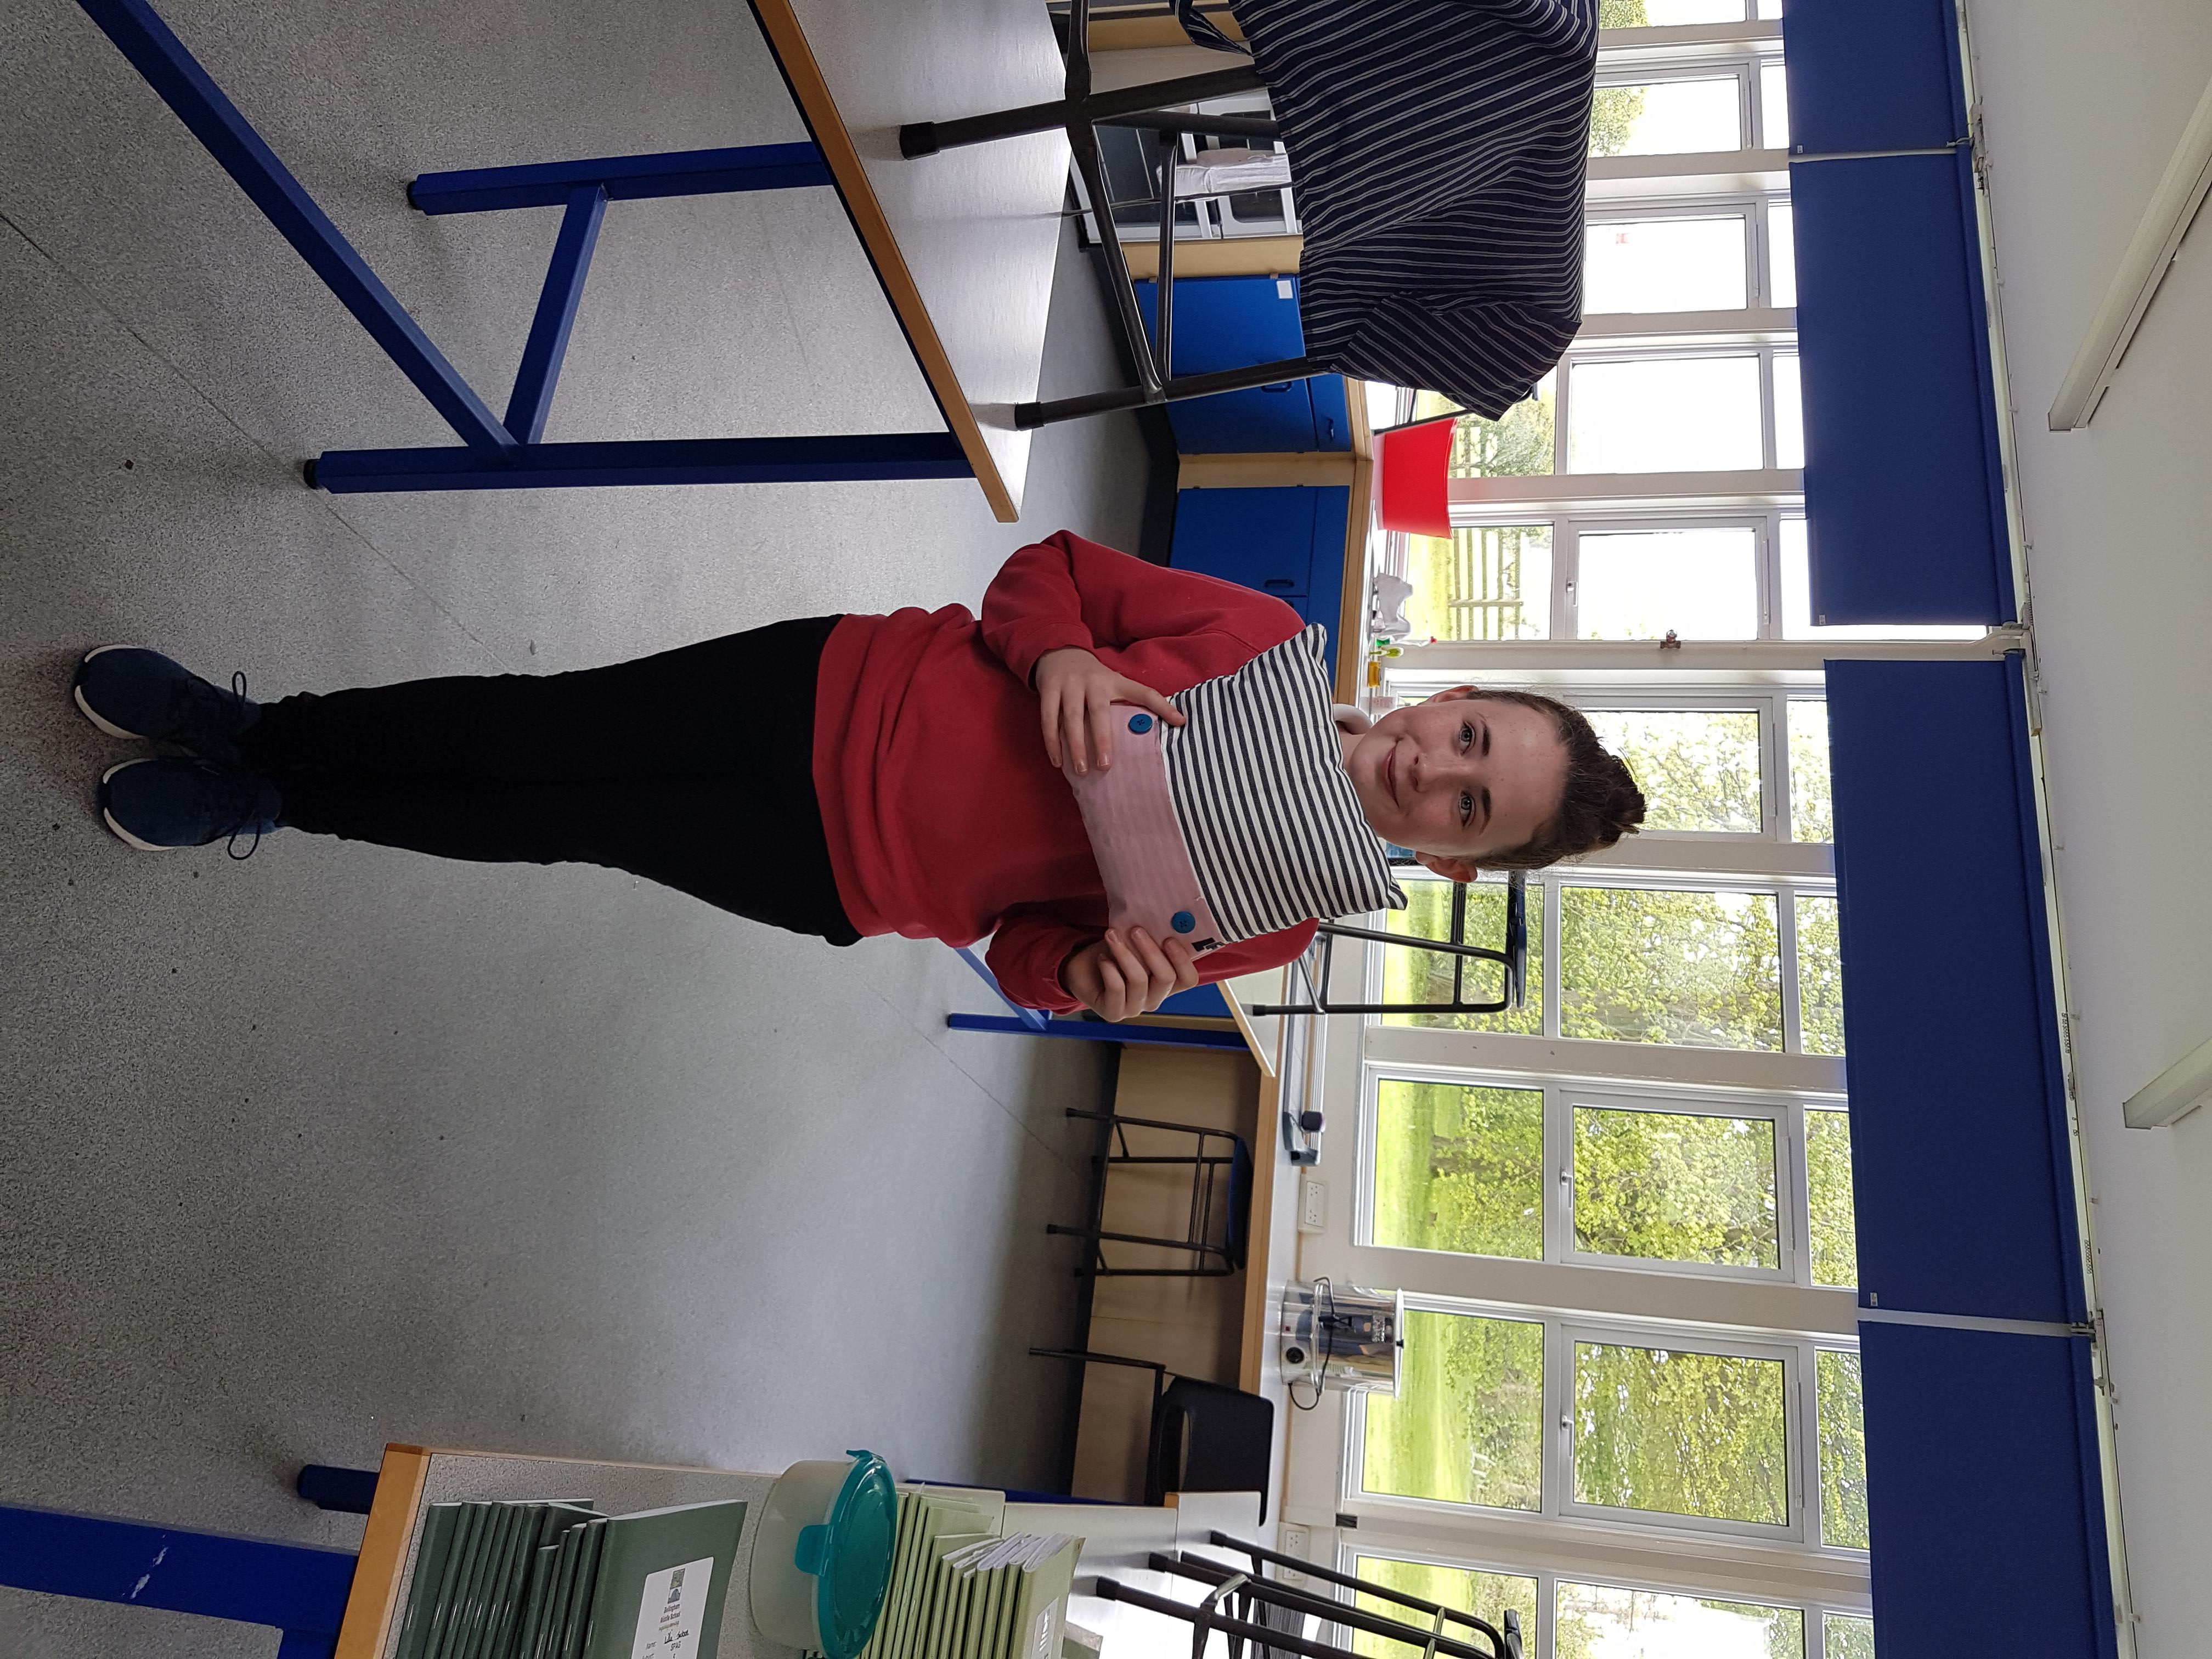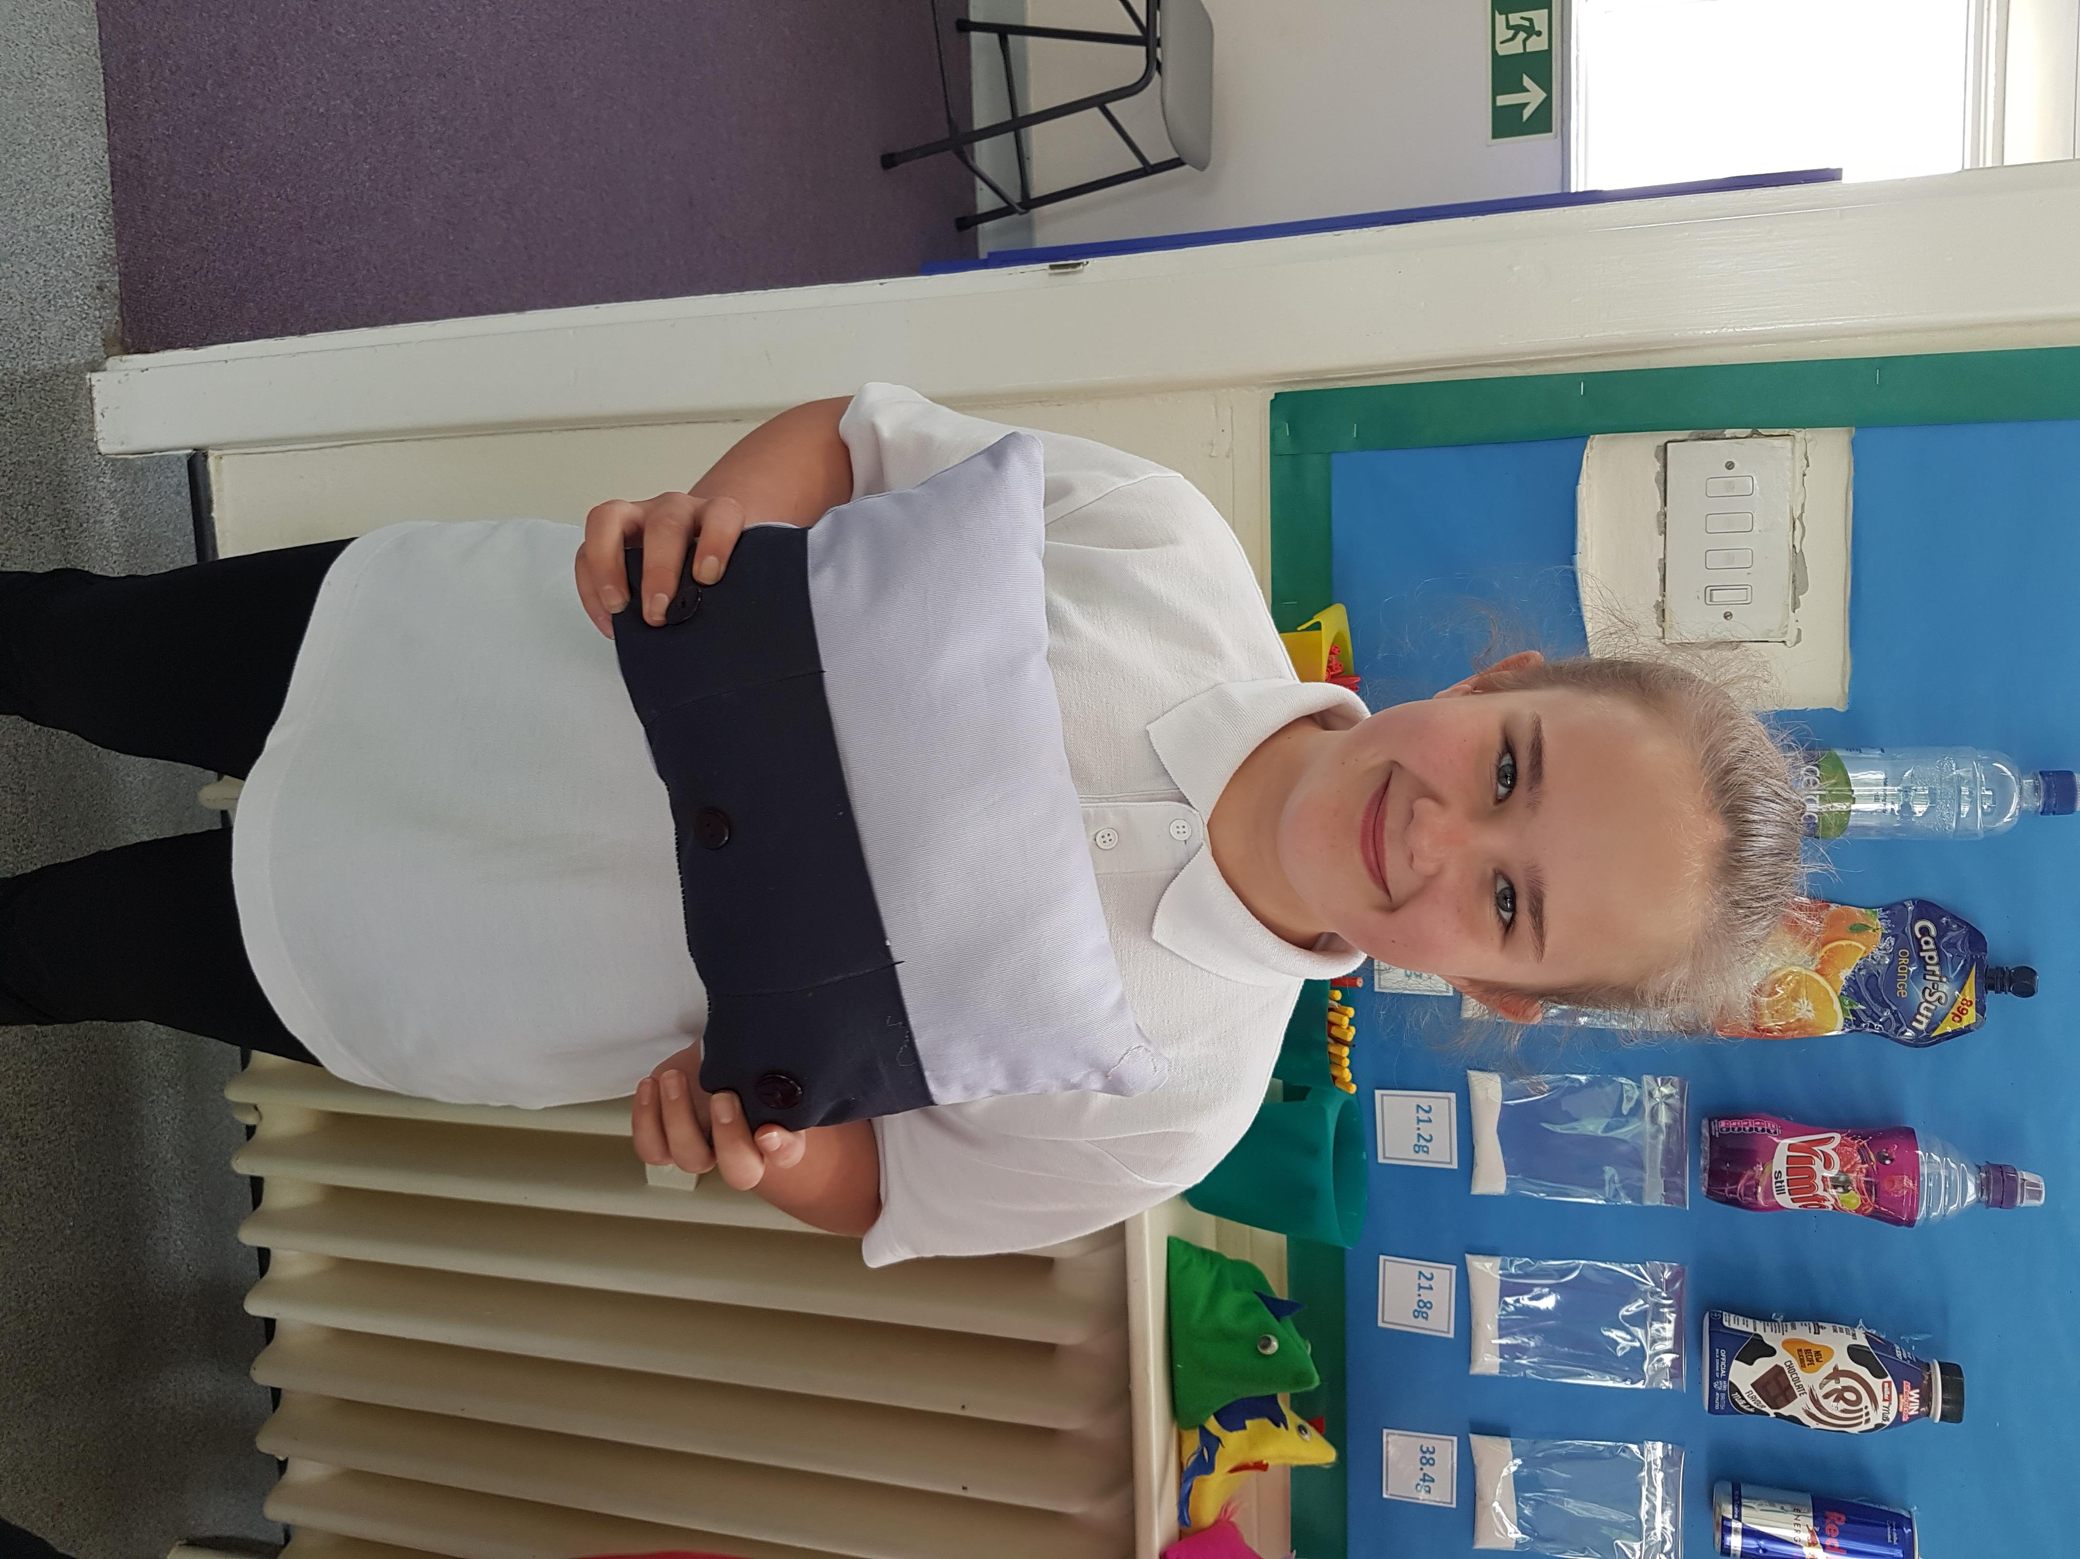
Some of our talented Y8 pupils have finally completed their cushions in Technology. The high quality of finished designs looked very professional indeed. What a lovely memento to keep from middle school!

MEMOS AND REMINDERS
 School Transport: Do remember that the deadline for school transport applications is 30th June 2018. Late applications may result in a delay in receiving bus passes.

Stationery Shop Current Stock List
Black pen | 50p
Blue pen | 50p
Pencil | 30p
Rubber | 20p
Pencil sharpener | 20p

Contacting school if your child is ill: Could all parents please inform us by 9.15 am if your child is not able to attend school due to illness. You can leave a message on the answerphone if the line is busy or email: middleadmin@bellinghampartnership.uk
Dinner Money: Please could we ask for your help here? If you are sending money into school to pay for several days at a time, this needs to be in a named envelope. It would also be much appreciated if you could put your child’s name on the back of any payment by cheque. Thank you for your support.
:
FORTHCOMING EVENTS AND KEY DATES
Tuesday 22nd May Non-uniform reward day for Kestrel and Peregrine Houses
Friday 25th May Break up for half term
Monday 4th June Back to school after half term
Thursday 7th June Area Athletics @ Wentworth Leisure Centre, Hexham
Friday 8th June KS3 Hawkhirst Trip
Tuesday 12th June Y5 Kielder Trip
Tuesday 12th June Y6, Y7 and Y8 Writers’ Workshop & Author Visit
Tuesday 19th June Y6 Maths & STEM Challenge @ Mowden Hall
Thursday 14th June World Cup Challenge Day
Monday 18th June “Be Safe” workshops in school – all years
Wed 20th June - Fri 22nd KS2 Kingswood Trip
Sat 23rd June County Athletics @ Gateshead Stadium
Tuesday 17th July Summer Production at 6pm

