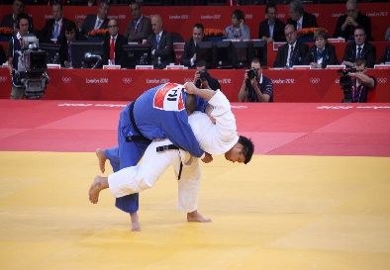  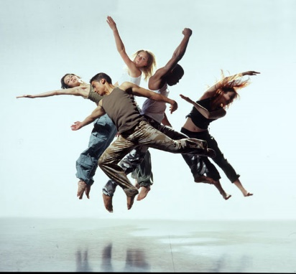

Summer Year 6 French Enrichment Homework

Create a written presentation describing your favourite sports.

Success Criteria:

* Say which sport you like
* Say which sport you love
* Say which sport you don’t like
* Say which sport you hate
* Say which is your favourite sport using (je préfère…)

Illustrate with pictures of the sports that you describe.