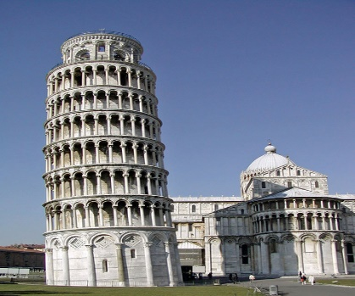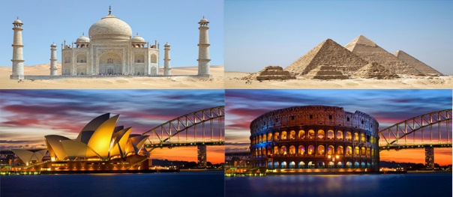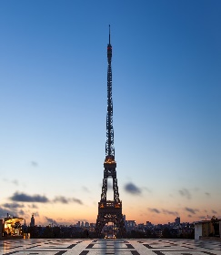
Autumn 2 Years 7 and 8 Modern Foreign Languages Enrichment Homework
Choose a country anywhere in the world. You are the brochure designer for the head tourist office in this country; your job is to encourage as many people as possible to visit this country.
Task
Design a brochure that includes the following Success Criteria:

- Two interesting and exciting geographical features that is worth visiting. Give details.
- Three historical places or monuments that are worth seeing. Give as much detail as you can.
- Describe the food that is traditional and local to this country.
- Two cultural activities worth seeing or taking part in, eg a particular sport, dance, type of traditional music, a festival or celebration of some sort.
- A number of useful words and phrases that you consider essential for a visiting tourist to get around and communicate with the local people.

Please make your brochure as colourful and detailed as possible. Feel free to add photos to illustrate the things and places you describe.

