Year 5 – Geography Enrichment Homework - Mapping Challenge
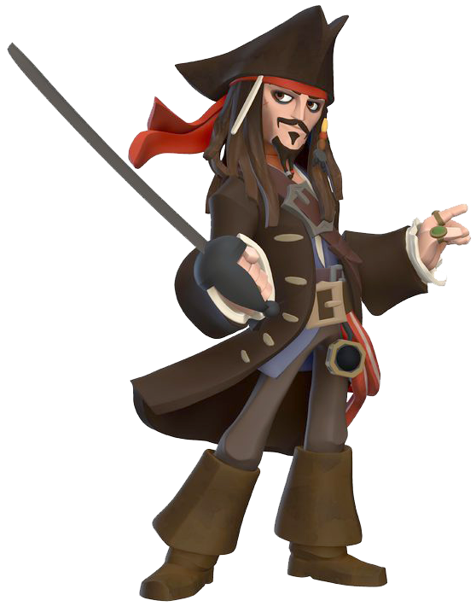
Captain Jack Sparrow has buried his treasure in a secret spot, on a secret island. Unfortunately, he has a terrible memory, so he has asked for your help. You need to design and illustrate the secret island on which his treasure is buried. Your map needs to be clearly labelled
using an effective and informative
Ordnance Survey map key.

Your map should be designed and coloured
on grid paper (available in school) and should be
stuck into your enrichment homework book.

To accompany your map, you need to write a detailed set of
instructions that Captain Jack Sparrow can follow in order to
once again find his treasure. When writing your instructions, you
must use the eight points of the compass, as well as make
reference to the map’s key. Finally, as an extra challenge, try to
include grid references within your instructions.

A copy of your instructions should be stuck
into your book alongside your map.

Task Overview:
- Design a hidden treasure map
- Create a key for your map
- Write a set of instructions to help Captain Jack Sparrow
find his treasure – don’t forget the compass points!

