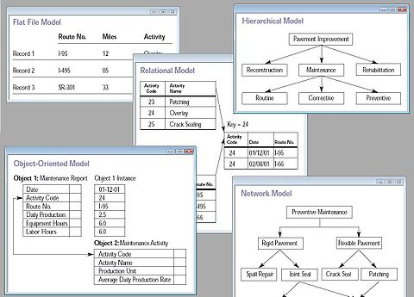
Year 6 Computing Enrichment - Using real world Databases

Databases are organised collection of information that can be searched and sorted.
We often use large computerised databases without realising it is a database. E.G. Accelerated reader and holiday company websites.

Your task is to search and sort real life databases to find helpful information for people.

To complete this task you need to help Mr Man plan a holiday to Naples.

He will be traveling from Newcastle to Naples between the 1st September to the 10th September.

He will be staying in Kathmandu for two nights and then the rest of his holiday in Pokhara.

He any wants to fly on the cheapest flights and would like a reasonably priced hotel.

To complete this task you will need to:
- Provide evidence of you using real life databases
- Show the holiday you have planned for Mr Man
- Write an explanation as to why you choose the flights and hotels.

