A friendship bracelet can be made as a gift or can be made together.
If you are struggling with your friendship, it can be nice to make them together so that you can talk through any problems you may be having and sort them out as you make your bracelet. A friendship bracelet can be the perfect way for friends to spend time together, creating something that they can both wear and that is meaningful.
There are many ways of creating friendship bracelets.
Friendship bracelets can be very complicated or they can be very simple. They can be worn by anyone and everyone.
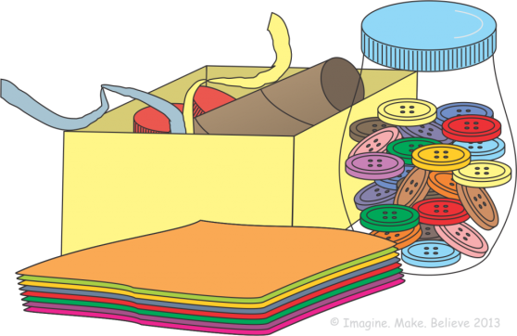
Here are some ideas on how to make them and what materials you will need:
1. A really simple friendship bracelet can be made by using:
- a piece of soft card
- colouring pens
- stickers
- craft materials
- a stapler

Instructions
Cut a piece of card 2-3cm longer than the measurement around your friend’s wrist.
Decorate the piece of card with coloured pens. You could write words that you think describe your friend and draw pictures that mean something to you both.
Use the stickers to decorate the bracelet or use any other craft materials you want to.
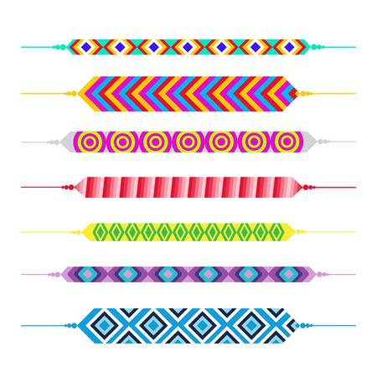
Once your bracelet is finished, give it to your friend to put around their wrist and tape the ends together.

2. A plaited friendship bracelet.
Instructions
Take 3 different colours of soft wool - you choose the colours.
The wool needs to be much larger than the measurement around your wrist.
Starting with lengths of wool as long as your full arm is a good idea.
Tie a knot at the end of all 3 of them so they are tied tightly together.
Separate the wool into 3 pieces pulling them apart from the knot at the top.
Take the piece of wool on the right and wrap it over the middle. Hold the right and the middle piece of wool tightly and then put the left piece over the middle piece. Continue to do this until you have plaited enough so that the bracelet will go around your friend’s wrist. Tie a knot underneath the plait.
Wrap the bracelet around your friend’s wrist and tie the two ends together in a knot. Be careful not to tie it too tightly around your friend’s wrist. Cut off any excess wool.

3. To make a beaded bracelet, you will need:
- a piece of soft wool (Cut it to 5cm longer than your wrist to allow you to have 2.5cm at each end to tie them together.)
- assorted beads
Instructions
Take the piece of wool and tie a knot at the end, leaving some space so you can tie the bracelet onto your friend’s wrist when it is finished. The knot needs to be big enough so that the beads will not slide over the knot and come off.
Start threading beads onto the wool until you are happy with how it looks.
Leave space at the end again and tie a knot at the end so that the beads don’t come off.
You can use the 2 remaining ends to tie them onto your friend’s wrist.

Your task:
1. Create a friendship bracelet using one of the methods above.
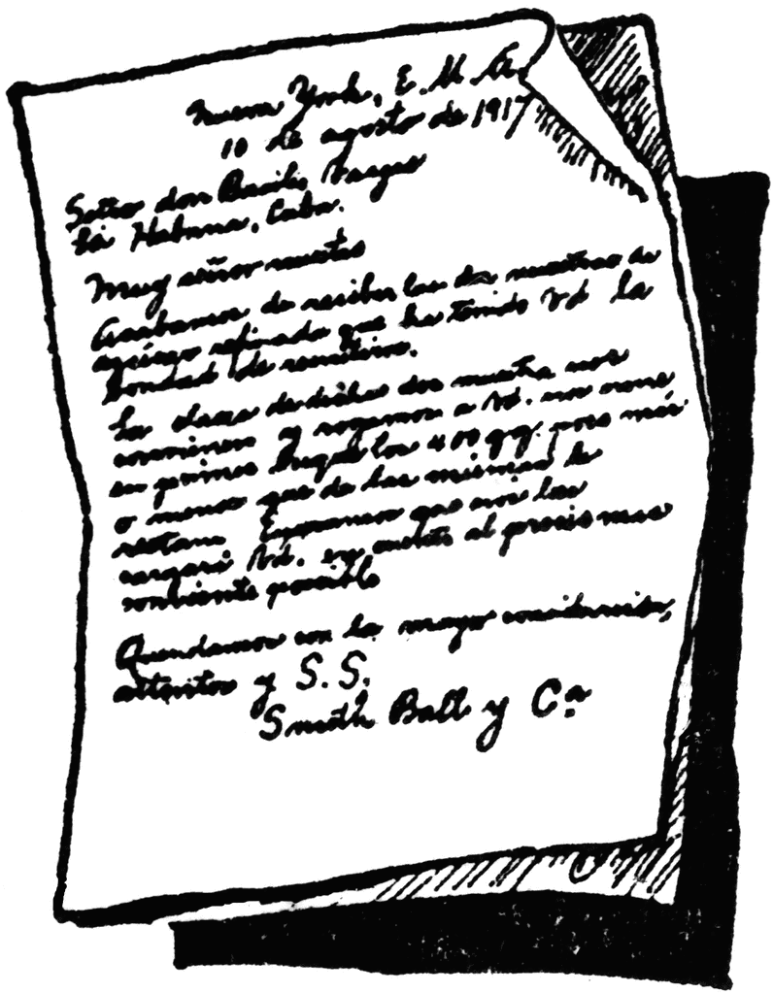
2. Write a letter to the friend you have chosen to give your bracelet to, stating clearly why you have chosen them and why you value their friendship.
You may want to mention:
• Personal qualities
• How/why they are a good friend
• Good times you’ve shared
• How you’ve worked out any problems you’ve had
• What you’re looking forward to in the future within your friendship

3. Make sure you take a photo of your friendship bracelet.
A copy of this photo and a copy of your letter must be glued into your enrichment homework book!

