Wool the wonder fabric

Wool is a super fabric! It has lots of amazing qualities that make it useful for making a range of products. However, man-made fabrics are frequently used in the fashion industry. Synthetic fabrics can damage the environment as they are not always biodegradable and can cause microfibres to be released into our rivers and oceans.

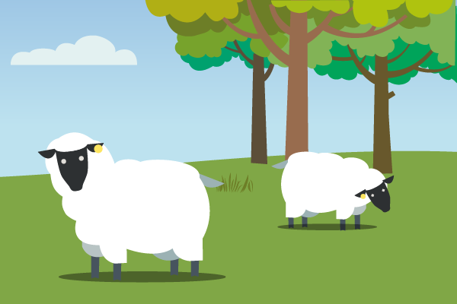
The Challenge:
Design a unique clothing product using British wool as a key material and explain its benefits for the wearer user and for the environment.

Alongside your design, I would like you to create an advertisement for your product that explains its benefits. You could present this as a poster, video, persuasive letter, presentation, speech- however you like!

You also need to show an understanding of the different types of British wool and why the chosen sheep breed is the right one for your product.

I will be marking your work based on four criteria:
- how well you’ve solved the problem,
- creativity & innovation,
- the environmental impact of your design,
- the benefits the design will have for farmers and food producers.

