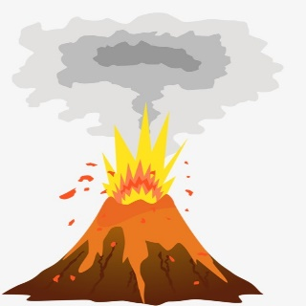
Year 7 Geography Homework Enrichment Activity Spring 1
Task – Design a set of Top Trumps cards that could be used with KS2 pupils to learn about named volcanoes
in a fun way.

There are at least 50 volcanic eruptions each year in the World and potentially 1500 active volcanoes altogether, most of these around the Pacific, so there are plenty to choose from.
- There should be a minimum of 12 cards but no more than 20.
- Each card should contain information on a volcano e.g. location, type, last eruption…
- A picture or drawing of the volcano – it can be printed out and stuck on!
- Each card should also have at least 4 categories. Possible suggested categories could include; deadliness or devastation potential, wow! factor, explosivity, unpredictability.
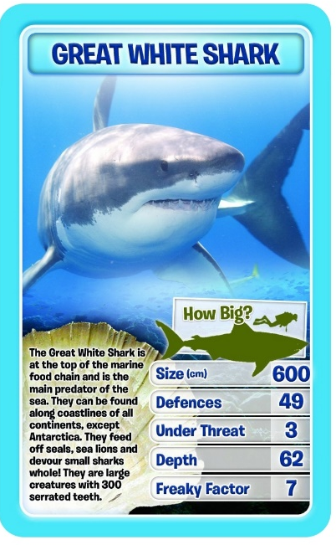
- A scale must be decided for each category and explained, along with instructions to play, with each set of cards.
Here is an example of a Sharks Top Trump card to give you
an idea of how to set it out.

All information must be presented in your own words,
while spelling, grammar and punctuation must be checked
before work is handed in.

A photograph or a copy of the actual cards should be stuck
in to your book. Cards should be printed on or stuck on to
card (which can be supplied) and cut out so they can be used.

Try your cards out on some KS2 friends or siblings and write a brief evaluation of between 100 and 200 words about how successful your Volcano Top Trumps cards are. Did they enjoy playing with them? Could they show that they had learned some interesting facts along the way?

Date Due:

