Pet Poetry Competition – KS2
Pet Poetry invites children of all ages to create a poem about their love for animals, from cute kittens or enormous elephants to lazy lizards.
There's lots of fun to be had writing your poem and here are a few ideas to help inspire you...
You could write an alphabet poem, a riddle or about something funny your pet has done! Perhaps you'd like to write about a dinosaur or mythical creature, or create your own make-believe pet to write a about. On a more serious note, you could write about endangered species, conservation of wildlife or from an animal's point of view. We welcome your poems in any style or format up to 30 lines.
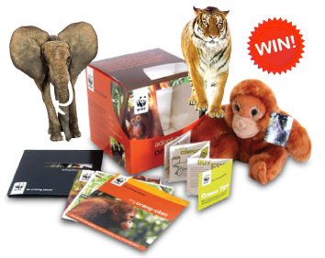
Prizes Up for Grabs!
We will select our favourite poems for inclusion in a special anthology and select a winner who will win an Animal Adoption package.
We will also have a runner-up who'll win a selection of books.

How to Enter
Write your poem in your enrichment book and on paper, remembering to include your name, age and postal address
Send your poem to:
'Pet Poetry'
Young Writers
Remus House
Coltsfoot Drive
Peterborough
PE2 9BF
Alternatively, email your poem to competitions@youngwriters.co.uk or click here to upload your poem online.

