HEADTEACHER MESSAGE:

What an incredible last week of term this has been! A huge thank you to all pupils, staff, families and friends of Bellingham Middle for making the close of our academic year so memorable.

Congratulations to Osprey House, our overall winners with the most house points this year at 4266. Kestrel House were the overall Sports Day 2019 winners. This year’s competition was extremely close, with the result of the last relay race deciding the placing of Osprey and Kestrel. Well done all!

On Tuesday evening, our fantastic cast of “Shakespeare Rocks” delighted a packed hall with another outstanding whole school production. Feedback has been overwhelming positive and we are so proud of all the children who have taken part as a cast member, stage hand, set designer or sound technician. You were all brilliant!

On Wednesday, our whole school reward outing to South Shield Beach was excellent, with outstanding behaviour from the children, who had great fun playing on the beach. We would like to thank Miss Mason as Visit Leader for all her hard work in coordinating this trip, along with the rest of our dedicated BMS team who accompanied your children on this special day.

Prom Night last night was stunning. This extra-special event is a celebration of our Y8 Leavers, as they prepare to leave BMS for high school. The Glitz and Glam theme certainly seemed to suit our KS3 pupils. Thank you to all families for supporting your children; they all looked amazing in their prom outfits. Prom Night would not be possible without the time and effort put in by staff, which ensured pupils had a night to remember forever. Our sincere thanks must go to them all, and particularly Ms Wilson and Mr and Mrs Carr for giving up their day off to decorate the hall – wow!

We would like to let you know that our caretaker, Paul Whalley, is leaving at the end of this term. He has been an excellent and highly skilled colleague, who will be very much missed. We wish him well on his new adventures as he moves on. Our new caretaker will be Dave Robson.

Do remember that our Leavers’ Assembly is at 2pm this afternoon. Come along and celebrate end of year achievements in this whole school celebration, particularly focusing on our Y8 Leavers. They have been a fabulous year group and we send them off to high school with all of our best wishes for a happy and successful future.

Finally, on behalf of all the staff at Bellingham Middle School, may I wish you a happy and restful summer holidays. We return to school on Tuesday 3rd September.

Kind regards,
Helen Samuels,
Acting Headteacher
____________________________________________________________________________________

LOOKING FOR SOMETHING TO DO TOGETHER?

COMMUNITY NEWS AND EVENTS

Saturday 31st August: Bellingham Show and County Festival: A perfect day out for all the family in the heart of the Northumberland countryside. Live bands, horses, sheep, terrier racing, children’s activities, good food, crafts, sheep, traditional games, wrestling, Northumbrian piping, beer tents, children’s rides, vintage vehicles, dog show, fell racing and much, much more. With continuous main ring entertainment and two beer tents as well as many other refreshments stands there is so much to see and do. 9am – 6pm. All welcome! Bellingham Show


Attendance this year – 95.22%



Please remember that holidays in term time will be unauthorised.

Thank you for supporting your child’s attendance this year.
As a school, we have exceeded our target of 95%. Well done!
_______________________________________________________________________________

Well done to all our wonderful House Prefects this year! These leadership positions have an important role to play in our school, with pupils carrying out a range of duties, often giving up their own time to support the school.

KESTREL  (4123) | MERLIN  (4122) | OSPREY  (4266) | PEREGRINE (4247)
Alex  Ryan | Morgan  Samantha | Alicia  Thomas | Paige  Imogen
Congratulations to all pupils in Osprey House : our overall winners for 2019!

South Shields
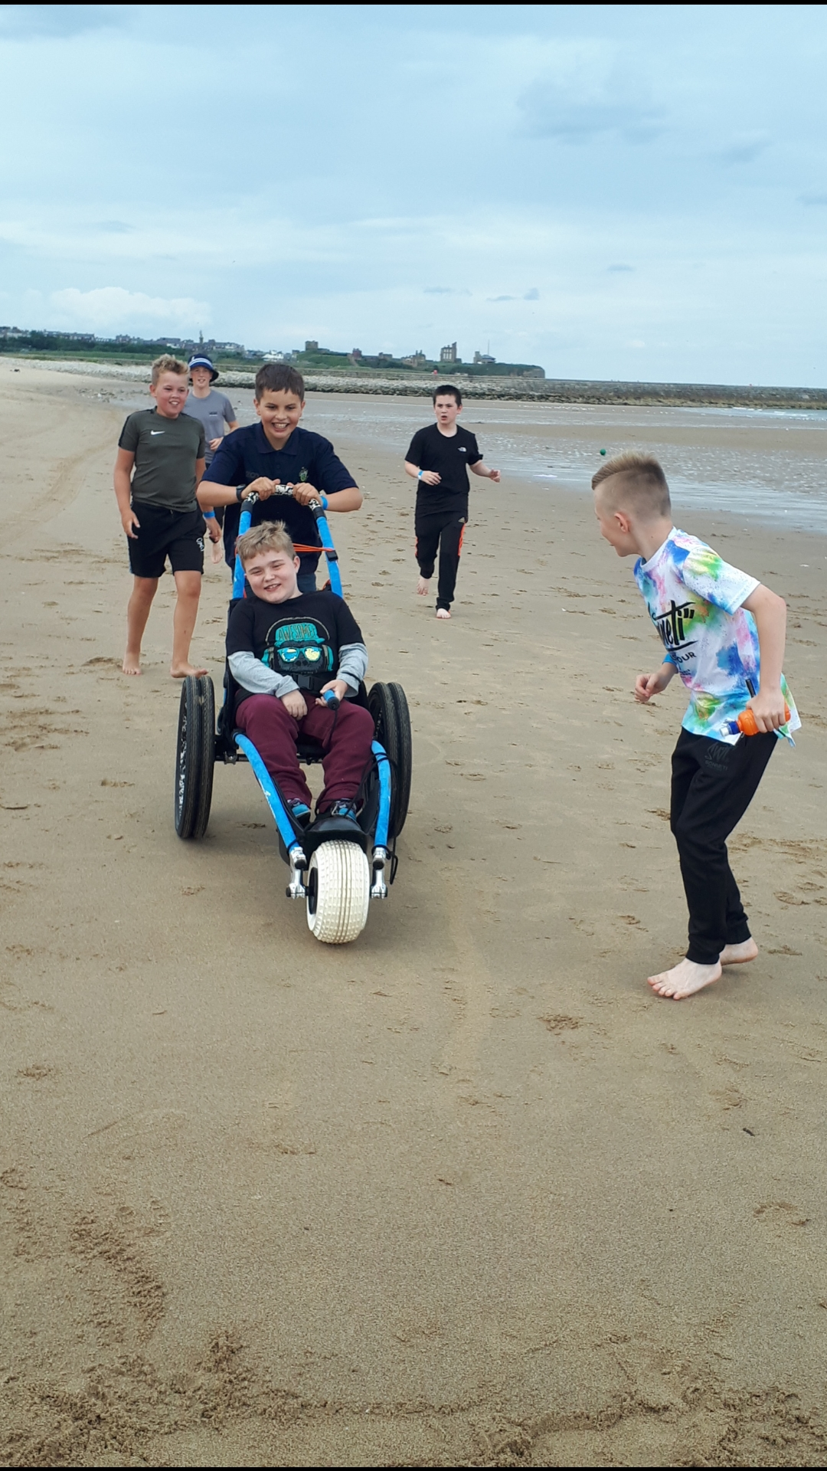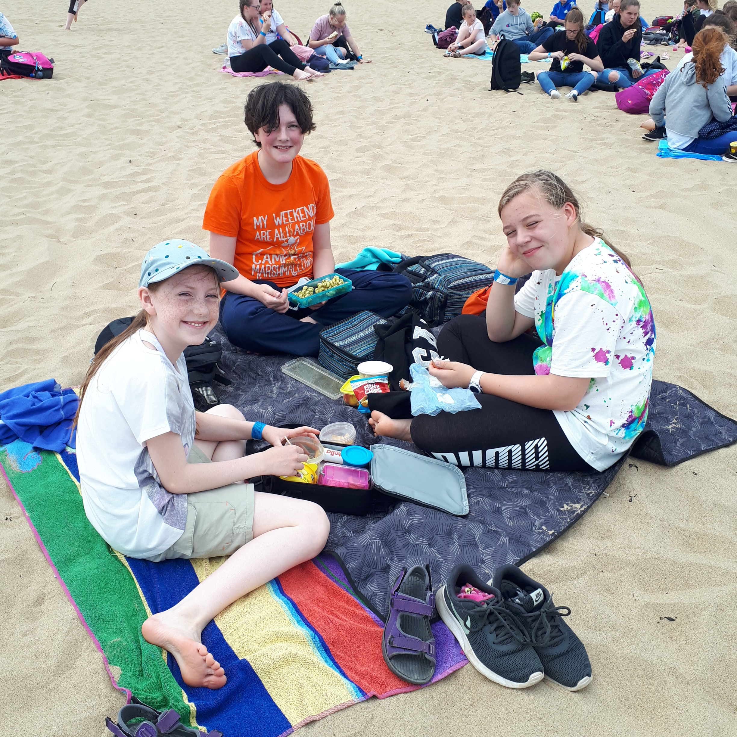
Time together to picnic and play as positive consequences for excellent behaviour this year.


Find your space. Take your place.
All the world’s a stage!
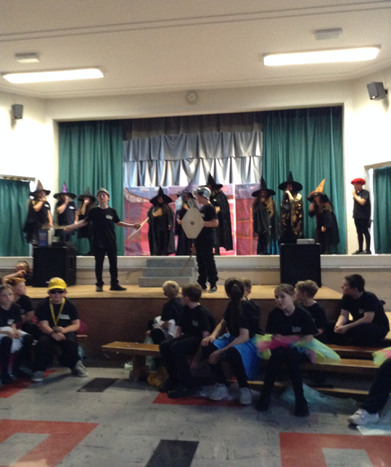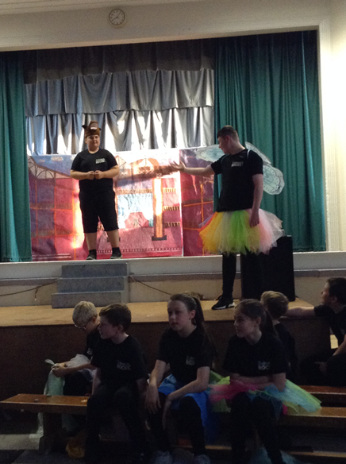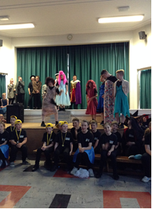


Goodbye and good luck to all our wonderful Y8 Leavers of 2019!
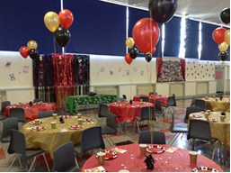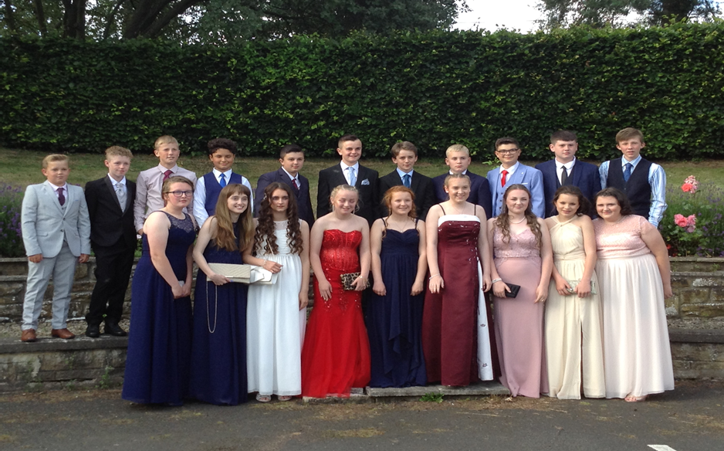

An open letter from the pupils of Bellingham Middle School to a very special teacher:
Dear Mrs Carr,
Thank you for being our brilliant, kind and lovely teacher. You have been one of the best ever for the following reasons:
- you smile every day
- you make learning fun
- you really care
- you never give up on us
- you encourage us to do our best
- you teach us how to eat well and live healthily
- you rescue our cooking (if possible)
- you give us confidence
- you share your top tips
- you show us that making mistakes is proof that we are learning
- you give us challenges
- you are enthusiastic and friendly
- you know how to make the difference we need
Positivity is your home, Mrs Carr. You are inspirational. We wish you happiness and success in your new job with the Forestry. Please keep in touch and come and visit us soon!
BMS Pupils 2019



MEMOS AND REMINDERS

UNIFORM: Whilst we are proud of how smart the vast majority of pupils look, please could we remind parents/carers that tracksuit bottoms, black leggings, cropped trousers and denim black jeans style trousers are NOT suitable for pupils to wear as school trousers. Please also note that school shoes from September should be black and polishable.

SCHOOL TRANSPORT: Please check that your child’s bus pass will still be in date for use next year. Contact School Transport if your child needs a renewed pass issuing for September. School Transport

Contacting school if your child is ill: Could all parents please inform us by 9.15 am if your child is not able to attend school due to illness. You can leave a message on the answerphone if the line is busy or email: middleadmin@bellinghampartnership.uk

Dinner Money: Please pay on the day or weekly on Mondays, using a named envelope. It is not possible to put credit on a tab. Whilst we would never see a child go hungry, we cannot afford to subsidise your child’s meal. If you require free school meals for your child, then please apply to Northumberland County Council. Call: 01670 623592 or apply online, using the link below. Thank you for your support.
Apply for Free School Meals
:
FORTHCOMING EVENTS AND KEY DATES

Fri 19th July Y8 Leavers’ Trip
Fri 19th July Leavers’ Celebration Assembly at 2pm
Fri 19th July End of term
Mon 2nd Sept Staff Training Day
Tues 3rd Sept Pupils return to school
Fri 12th Sept OSPREY House Reward Day (non-uniform)
Fri 18th Oct KS3 Democracy Workshop
Fri 28th Oct Last day of autumn first half term for pupils
Mon 4th Nov Staff Training Day
Tues 19th Nov KS2 Healthy Living Workshop



