YEAR 7 HISTORY HOMEWORK – SPRING 2

Learning Objectives:
- To research and present a project on the subject of the War of the Roses.
Task:
You need to research the key events and key figures that played a part in the War of the Roses (1455-1485 .
You need to produce a project contains the following:
- A timeline of key events from the war.
- The key reasons why the war started.
- Profiles of the kings in charge of the country during the war.
- How did the war end and what did this lead to?

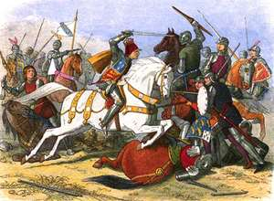

Deadline:

