YEAR 7 HISTORY HOMEWORK – SUMMER
This year commemorates the 75th anniversary of D-Day. The Normandy landings were the landing operations on Tuesday, 6 June 1944 of the Allied invasion of Normandy in Operation Overlord during World War II.
Codenamed Operation Neptune and often referred to as D-Day, it was the largest seaborne invasion in history. The operation began the liberation of German-occupied France (and later Europe) from Nazi control, and laid the foundations of the Allied victory on the Western Front.

Learning Objectives:
- To describe and explain the key events and significance of D-Day.
Task:
- Write a detailed timeline of the event, highlighting the key figures involved in the operation. Your timeline should begin before the landings and finish with the aftermath of the operation.
Or
- Imagine you are a young British soldier being sent to the beaches of Normandy. Write two diary entries:
- The day before landing at Normandy – how are you feeling/what are your main worries/how will you get there?
- The day after landing at Normandy – how was the journey/what did you see on the beach/how did you act?

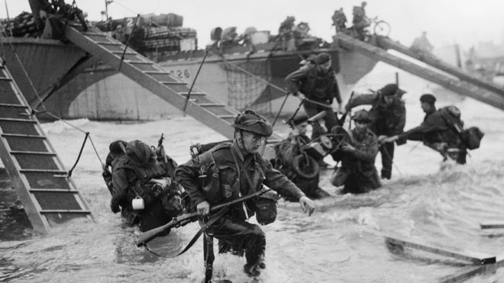
Use the following websites to help you:
https://marinamaral.com/2019/06/d-day-in-color/

https://www.dday.org/

https://www.bbc.co.uk/newsround/27711699

https://www.history.com/topics/world-war-ii/d-day-allied-invasion-at-normandy-video

