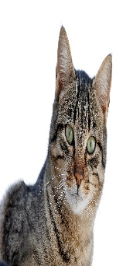
Year 5 French Enrichment Homework

Create a poster of two of your favourite animals or pets in French and colour them in.

Success Criteria:
- Write two sentences as if you have these pets using “j’ai”
- Describe the animals using colours as adjectives (after the noun)

