Year 6 Humanities Enrichment - Your local area

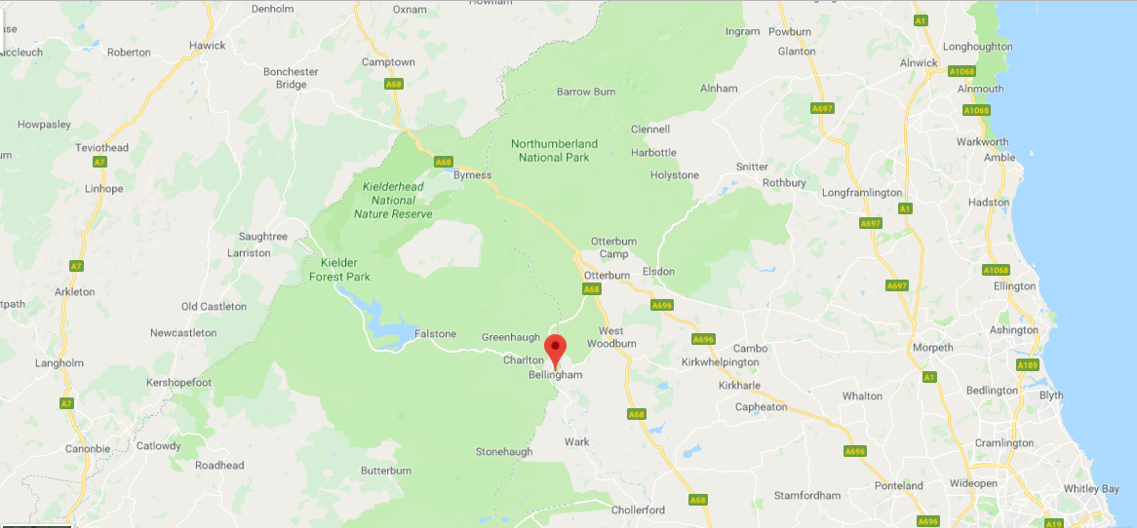

Task:
To research the history and geography changes of a local area.

How to complete the task:
- You need to select a local area e.g. Kielder, Otterburn or Bellingham.
- You will need to identify the area on a local map
- You will need to look at different maps to identify how this local area has changed over many years
- You will need to carry out research on the history of your chosen local area
- Finally you will produce an information leaflet (minimum one A4 side) about the history of this local area and the geographical changes to this area.

Success criteria

Includes a map with the local area identified on
Included research of how the local area has changed over time
Included research into the history of the local area
write or typed a detailed information leaflet about the local area
The leaflet must include a range of punctuation
The leaflet must include some adventurous vocabulary
The leaflet must be well presented

