HEADTEACHER MESSAGE

Our exciting curriculum is now well underway for all year groups, with a full enrichment programme on offer. Not even three weeks into the autumn term and some of our new Y5 pupils are already speaking Spanish as well as French! Our new Maths Whizz programme to accelerate progress in maths has been introduced, with a personal learning journey mapped carefully for individuals. We have been particularly impressed with the effort and progress made so far by our KS2 pupils, some of who have already earned their first Maths Whizz Gold Awards. Meanwhile, KS3 pupils have made a flying start to reading this year with the introduction of dedicated English Literature lessons with Mr Ramshaw, as they get ahead for high school. There are new books galore in our school Accelerated Reader library, thanks to Mrs Stutchbury and her team of pupil librarians. Do support your child by limiting screen time and insisting on reading instead.

We were delighted to welcome Parliament Outreach into school this week for a whole school assembly about the democratic process in the UK. Y6, Y7 and Y8 also enjoyed specialist workshops where they participated enthusiastically in full debates and worked as teams against the clock to produce party election campaigns, complete with manifestos. Gillian Porter, our guest speaker, was impressed by the active engagement and passion shown by our pupils when debating the sugar tax, the plastic bag charge or whether schools should follow Finland’s lead and ban homework. This bodes well for our forthcoming Pupil Forum Elections. Please encourage your child to put themselves forward and make their voice heard to make a difference for others.

We would like to take this opportunity to provide the following update for you. The Office of the Schools’ Adjudicator (OSA) is the government office which will make a final decision about closure for our school. Yesterday, the OSA confirmed with us that there is to be a public meeting at Bellingham Middle School on Friday 12th October at 5pm to which all parents, carers and community members are invited. You are all welcome to attend and there will be opportunity to speak for those who wish to.

Kind regards,
Helen Samuels,
Acting Headteacher
______________________________________________________________________________________

LOOKING FOR SOMETHING TO DO TOGETHER THIS WEEKEND?

COMMUNITY NEWS AND EVENTS
Now until 20th October 2018: Matisse Art Exhibition (FREE) Drawing with Scissors @ Queen’s Hall, Hexham. The French painter, sculptor and designer, Henri Matisse (1869-1954) was one of the 20th century’s most influential artists. This exhibition includes many of his iconic images, such as The Snail. Open 10am – 4pm on Saturdays, as well as during the week.


6th and 7th October 2018: Discovery Bricks Lego Show (Advance booking online essential). For Lego fans, this event promises to impress with the sheer range of construction on display. Discovery Centre, Newcastle


Attendance this week – 95.7%


Thank you! We really appreciate all your efforts in getting to school on time, ready to start our day promptly.

Did you know?

UNCRC Article 28 – Every child has the right to learn and go to school.

_______________________________________________________________________________

SCHOOL NEWS AND EVENTS

Maths Whizz: all KS2 pupils already have their personal login details and can access Maths Whizz through the school website. Look online to learn more with your child. Ask them to show you around their online study. Your child’s work is monitored carefully, and support is given to unpick misconceptions and ensure progress is made. Now that staff training has been completed, some KS3 pupils will also join in from next week.


Y6 pupils have started their online Rising Stars programme, which supports grammar, punctuation and spelling. They have been given personal login details and can access their work through the Rising Stars link on the school website. Miss Mason will set homework in your child’s Rising Stars GPS book each week. If your child logs on, you can offer support by taking a look online at the corresponding animation together.

Reading Books: all pupils should have their AR reading book with them each day. We expect everyone to read at home as well as at school. Once a book has been finished, pupils complete a quiz at school online to check their understanding. Our library is full of suitable titles for your child to enjoy. If your child wants to read a book from home, you can check if it is on the AR system by looking on www.arbookfind.co.uk . Mrs Robinson or Mrs Stutchbury can help you if you would like to know more about AR.


Handwriting Winners: Congratulations are due to the following pupils, who have won awards for their beautiful handwriting in the 2018 Bellingham & District Leek Show…
1st Prizes: Daniel (Y5) Jenny (Y6) David (Y7) Erin (Y8)
2nd Prizes: Harry (Y5) Isla (Y6) Ruby (Y7) Joseph (Y8)
3rd Prizes: Elizabeth (Y5) Isaac (Y6) Lucy (Y7) Alicia (Y8)


PREFECT ZONE

Meet our new school prefects for 2018-19: Imogen, Paige, Ryan, Thomas, Morgan, Alicia, Samantha and Alex. We asked them to identify their particular strengths and what they hope to offer the school…
I am looking forward to having a bigger role to play in school. It will be a good opportunity to express my ideas and beliefs about our school. have enjoyed playing in the playground and making new friends.
I am organised, I am a good listener and I am resilient. I am looking forward to events.
I am responsible, I am easy to talk to and I will listen. I am looking forward to taking on an extra responsibility. I think this is a good opportunity to help develop my confidence further.

I am looking forward to having more responsibilities and helping people.

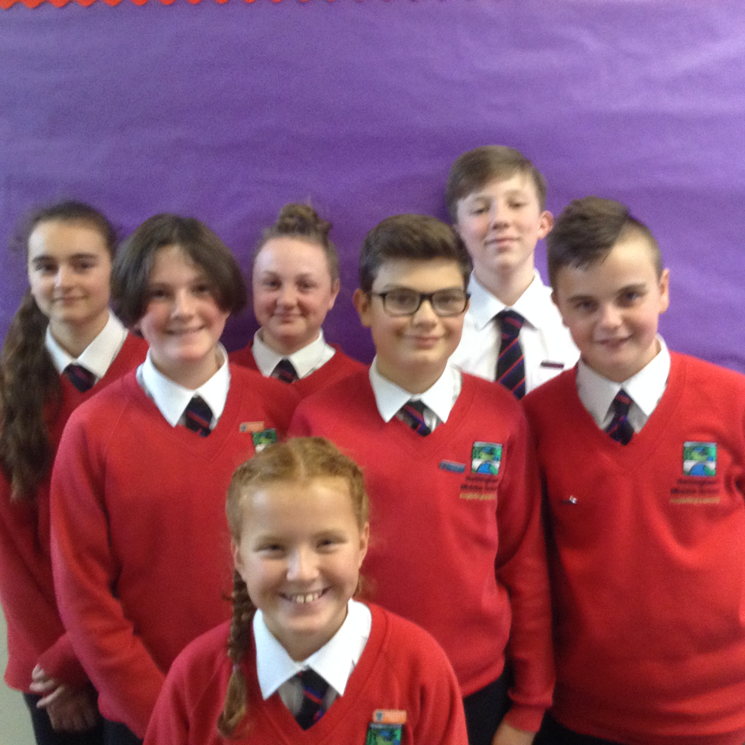
I will listen to people and help them if they needed it, I am also resilient. I am looking forward to doing events.
I am approachable and I can help other students with academic things as well as their problems. I can be responsible and get things done when I need to.

I am looking forward to the coming year because I will be helping at events like discos and coffee mornings and doing house points.
I think that this will be a good opportunity for me to get better at speaking in front of lots of people.

MEMOS AND REMINDERS
Admissions 2019: Further to the letter you will have received from Northumberland County Council about admissions for the next academic year, we appreciate that this is an anxious time for families. If you happen to have any questions, or require any support in understanding what you need to do or not do by the deadline of 31st October 2018, then please do not hesitate to get in touch.

 Bike Helmets: Your child must wear a bike helmet as he or she cycles to or from our school. We will let you know if we notice your child without a helmet and have to insist that he or she does not ride until one is worn. Please remind your child to stay safe on our roads by wearing a helmet. Further Bikeability training will be available next term.

Contacting school if your child is ill: Could all parents please inform us by 9.15 am if your child is not able to attend school due to illness. You can leave a message on the answerphone if the line is busy or email: middleadmin@bellinghampartnership.uk

Dinner Money: Please pay on the day or weekly from September. It is not possible to put credit on a tab. Whilst we would never see a child go hungry, we cannot afford to subsidise your child’s meal. If you require free school meals for your child, then please apply to Northumberland County Council. Call: 01670 623592 or apply online, using the link below. Thank you for your support.
https://online.northumberland.gov.uk/citizenportal/form.aspx?form=Free_School_Meals
:
FORTHCOMING EVENTS AND KEY DATES

Tues 25th Sept British Army Visit - Resilience
Fri 28th Sept MacMillan Coffee & Cake Afternoon
Friday 5th Oct 2nd instalment for London trip – pay by today
Wed 10th Oct World Mental Health Day – “Hello Yellow”
Friday 12 Oct OSA Public Meeting at BMS – 5pm – all welcome
Mon 15th Oct Democracy Week: KS3 Visit to County Hall
Fri 26th Oct Pupils attend school for last day of autumn first half term
Mon 5th Nov Teacher Training Day – no pupils
Tues 6th Nov Start of autumn second half term begins
Fri 16th Nov Children in Need Day
Fri 21st Dec End of autumn term

