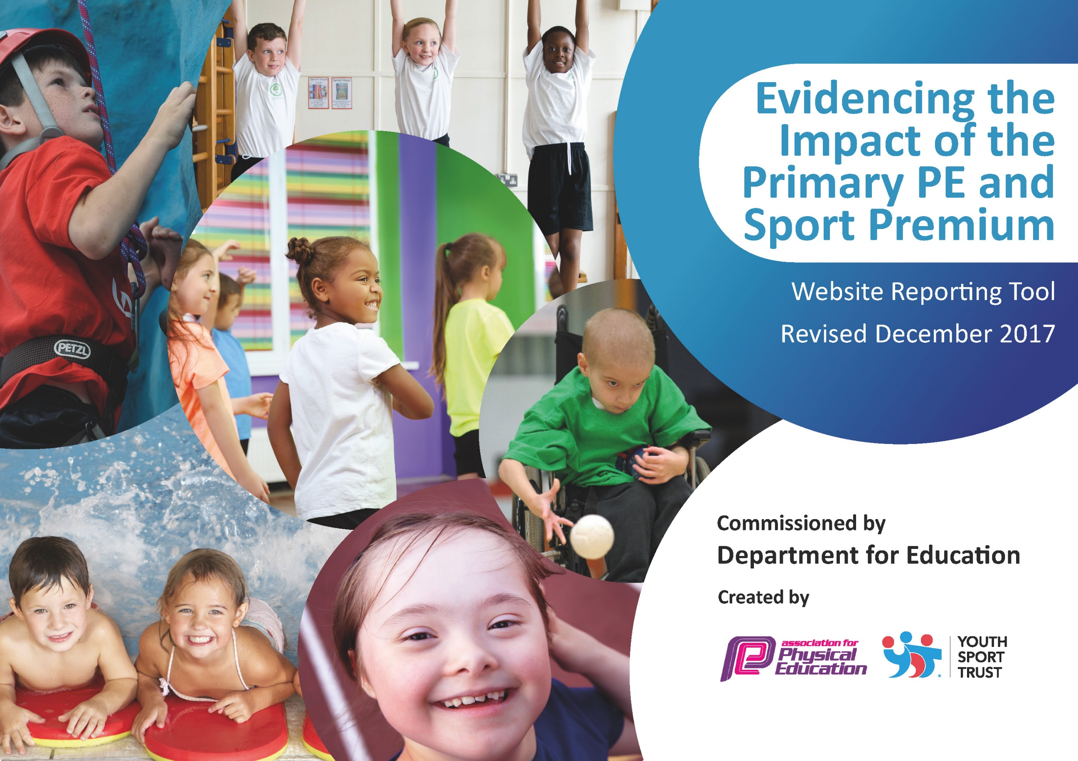

Schools must use the funding to make additional and sustainable improvements to the quality of PE and sport they offer. This means that you should use the Primary PE and Sport Premium to:

- develop or add to the PE and sport activities that your school already offers
- build capacity and capability within the school to ensure that improvements made now will benefit pupils joining the school in future years

Please visit gov.uk for the revised DfE guidance including the 5 key indicators across which schools should demonstrate an improvement. This document will help you to review your provision and to report your spend. DfE encourages schools to use this template as an effective way of meeting the reporting requirements of the Primary PE and Sport Premium.

We recommend you start by reflecting on the impact of current provision and reviewing the previous spend.
Under the Ofsted Schools Inspection Framework, inspectors will assess how effectively leaders use
the Primary PE and Sport Premium and measure its impact on outcomes for pupils, and how effectively governors hold them to account
for this.

Schools are required to publish details of how they spend this funding as well as on the impact it has on pupils’ PE
and sport participation and attainment.
We recommend regularly updating the table and
publishing it on your website as evidence
of your ongoing review into how you are using the money
to secure maximum, sustainable impact. To see an example of how to complete the table please click HERE.

Support for review and reflection - considering the 5 key indicators from DfE, what development needs are a priority for your setting and your students now and why? Use the space below to reflect on previous spend, identify current need and priorities for the future.
Key achievements to date: | Areas for further improvement and baseline evidence of need:
- Increased achievement in PE lessons.  - Increased pupil skill development in a variety of sports.  - Increased participation in competitive school sport.  - Improved personal health and well-being.  - Improved attitudes towards learning.  - Improved/increased resourcing PE/sports equipment in school.  - Improved staff knowledge and skills in the teaching of PE and Sport.  - Increase in students participating in extra-curricular sport.  - Increase in number of girls participating in extra-curricular sport.  - Increase in awareness of disability sport provision and assessment.  - Increase in students participating in Sports Leaders programme. | - Continued improvement for some pupils in personal health and wellbeing.  - Continued pupil skill development in a variety of sports.  • Continued staff development in the teaching of PE and Sport.  - Continual development of teaching/curriculum to ensure and increase in SEND/ female students reaching secure in a greater range of sports.  - Continual increase in awareness of disability sport provision/build links with local organisations.  - Development of PE assessment procedures.  - Increase links with local sports clubs/organisations.

Meeting national curriculum requirements for swimming and water safety | Please complete all of the below*:
What percentage of your current Year 6 cohort swim competently, confidently and proficiently over a distance of at least 25 metres? | 92%
What percentage of your current Year 6 cohort use a range of strokes effectively [for example, front crawl, backstroke and breaststroke]? | 53%
What percentage of your current Year 6 cohort perform safe self-rescue in different water-based situations? | 70%
Schools can choose to use the Primary PE and Sport Premium to provide additional provision for swimming but this must be for activity over and above the national curriculum requirements. Have you used it in this way? | Yes/No  The school has allocated funding to support one of our SEND students to participate in swimming lessons.
*Schools may wish to provide this information in April, just before the publication deadline.

Action Plan and Budget Tracking
Capture your intended annual spend against the 5 key indicators. Clarify the success criteria and evidence of impact that you intend to measure to evaluate for students today and for the future.

Academic Year: 2017/18 | Total fund allocated: £16,530 | Date Updated: 15/3/2018
Key indicator 1: The engagement of all pupils in regular physical activity – Chief Medical Officer guidelines recommend that primary school children undertake at least 30 minutes of physical activity a day in school |  |  |  | Percentage of total allocation:
 |  |  |  | 28%
School focus with clarity on intended impact on pupils: | Actions to achieve: | Funding allocated: £5,030 | Evidence and impact: | Sustainability and suggested next steps:
Whole school clubs to continue in, football, rugby, badminton, cricket, unihoc and table tennis  Updating and replacing of PE equipment/facilities to ensure adequate provision in all lessons  Updating and replacing of break time equipment to ensure adequate provision during unstructured time  Developing the existing house system to incorporate further house sport competitions  First School links and  transition work | - Staff to continue to run clubs at lunch and after school  - Support and training provided to staff as needed  - Teams selected and entered  into competitions  - Increased numbers of students participating  - Focus on improving equipment, with main emphasis on gymnastics/recoating gym floor  - Emphasis on push on disability sports, buying in equipment for specific sports.  - Introduce more diverse equipment to meet the needs of all students across the school ensure break time is more structured and enjoyable  - Half-termly house tournaments in lessons, across a variety of sports  - Results pinned on to notice board to develop interest and awareness  - Cumulative points from the competitions are added up throughout the year to Work with SR to coordinate  - First school transition PE activities  - Sports leaders to run a sports day at BFS |  | - Registers taken in alignment with School Games accreditation  - PP, gender, SEND data analysed  - 64% of pupils have participated in at least 1 club this year  - 4 football teams across the school  - Pupils are more active in PE lessons – with overall fitness much improved.  - Standards achieved in PENC are improving with over 60% currently achieving end of KS2 attainment target  - Attitudes to learning improved – better effort shown in lessons/less low level disruption  - Students bringing their PE kit more often than last year  - Students with greater access to a wide range of sports equipment at break time  - Overall improvement in behavior at break times  - Students enjoying break time more than before  - All pupils represent their house in a selection of sports across the year  - Points awarded to school house system  - Building links with first schools  - Greater awareness of sport/PE at BMS for first school staff and students | - Run throughout the year.  - Priorities key areas of equipment/facilities that need attention  - Attempt to get more staff to assist/lead on after school sport  - Look at possibility of offering more external coaching in various sports  - Build links with local sports clubs
Key indicator 2: The profile of PE and sport being raised across the school as a tool for whole school improvement |  |  |  | Percentage of total allocation:
 |  |  |  | 6%
School focus with clarity on intended impact on pupils: | Actions to achieve: | Funding allocated: £900 | Evidence and impact: | Sustainability and suggested next steps:
To develop the Sports Leaders programme  Sports leaders and equipment monitors working with staff during curriculum time and extra-curricular activities  Achievements celebrated in assemblies and information shared on notice boards  Promote non PE staff assisting with clubs and events  PE being an option on Friday afternoon enrichment programme  Purchase of IPEP to assist with assessment procedures | - Sport Leadership lessons added to PE curriculum.  - DD in to work with Sports Leaders  - Students to run own session/events in liaison with BMS/BFS or assist with area competitions  - Sports leaders audit equipment and highlight requirements for lessons/break times  - Use school notice boards to highlight achievements and give information regarding clubs/fixtures  - Updates to SLT/admin  - Clear staff roles and responsibilities for House tournaments  - Support and training for staff interested in helping at sports clubs  - Termly activities chosen as an option in school enrichment programme: Autumn (Fitness), Spring (Orienteering), Summer (Team/Alternative sports)  - Use of IPEP to assist with planning, assessment and evaluating procedures during curricular time. |  | - Pupils have developed confidence and skill set to deliver PE/sport sessions and events to peers and younger children  - Pupils have assisted with running external events within area (tag rugby at Tynedale/tennis at PCHS)  - Greater awareness/understanding on main equipment requirements  - Pupils are proud to be involved in assembles/photos on notice boards etc. which is impacting on confidence and self-esteem.  - Increased self-esteem/confidence are having an impact on learning across the curriculum  - TF assisting with girls football fixtures  - 41% of KS2 students chose orienteering as their enrichment option for Spring term.  - “Non-sporty” students accessing sports which require more mental capabilities and problem solving  - Greater understanding of assessment procedures, making the process more objective rather than subjective | - Continue to access leadership opportunities in the local area

Key indicator 3: Increased confidence, knowledge and skills of all staff in teaching PE and sport |  |  |  | Percentage of total allocation:
 |  |  |  | 6%
School focus with clarity on intended  impact on pupils: | Actions to achieve: | Funding  allocated: £1000 | Evidence and impact: | Sustainability and suggested  next steps:
We have a specialist P.E teacher who has a full time P.E timetable to allow high quality Sports Provision. As he delivers to both KS3 and KS2 we have not allocated any funding from Sports Premium to his wages however, an allocation for training was given to maintain this high quality provision additional to whole school CPD budget.  Upskill the staff in current developments, especially in physical literacy developments. CPD opportunities for staff members.  When required, a specialist TA is required to support certain lessons, to enable individual student achievement.  At times cover is required to allow the PE teacher to follow the team to participate in a competition. Specialised PE cover is supplied on many occasions.  Damien Dimmick (SSP) in school delivering specialised Sports Leader sessions to students | - Increase achievement in PE.  - 95% of students required to make expected progress or better  - Ensure suitable timetabling  of staff  - Ensure PE staff are able to  maintain and upskill  relevant knowledge by  attending suitable courses  - FP/TF/JK supported in assisting 1 to 1 with SEND students during PE lessons.  - Access in-house and external providers to develop understanding of delivering PE and inclusion of all pupils  - Ensure AS is up to date with current curriculum delivered in school  - Sports Leaders aiming to develop confidence in leading/assisting with organised sporting activities |  | - Increased achievement in PE.  - Inclusion in PE YST course attened by PE lead – greater awareness of disability sport and differentiation methods  - All staff have better subject knowledge and increased confidence in subject delivery. Increased confidence and better subject leading skills enabling the subject leader to lead professional learning for all staff. This resulted in staff benefiting from courses and new knowledge and increased confidence which fed into lessons.  - AS worked in the school form 30 years before retiring. She is aware of the current curriculum and able to challenge all pupils through her knowledge and experience  - Pupils have developed confidence and skill set to deliver PE/sport sessions and events to peers and younger children  - Pupils have assisted with running external events within area (tag rugby at Tynedale/tennis at PCHS) | - Continue to access external AfPE accredited courses for PE staff  - Staff to advise of any areas they feel they require additional support from the PE Lead.  - Additional training needs of staff to be explored to see if there are any local courses/CPD training they could attend.  - Staff meetings and twilights ran by PE Lead and SSP.
Key indicator 4: Broader experience of a range of sports and activities offered to all pupils |  |  |  | Percentage of total allocation:
 |  |  |  | 22%
School focus with clarity on intended  impact on pupils: | Actions to achieve: | Funding  allocated: £3600 | Evidence and impact: | Sustainability and suggested  next steps:
Continue to offer a wider range of activities both within and outside the curriculum in order to get more pupils  involved  Focus on teaching disability sports to students to enhance awareness  Swimming lessons added to curriculum as enrichment option for selected students | - New activities offered during curriculum time (dance with Molly Stroyan), enrichment activities, boccia and after school (American Football)  - Trip to Hawkhirst  - Enhance students’ knowledge in boccia, goalball and new age curling  - Offer swimming as an enrichment option to selected students to access the curriculum more effectively |  | - Increased enthusiasm/studentas bringing kit to lessons. Greater understanding of sport.  - Students with increased understanding of disasbility sports rules and rerquirements.  - All 107 students participating in the Sport Relief Boccia tournament. | - Gauge from pupils the clubs they would most support being delivered.  - Continue to embed disability sports into curriculum.  - BMS Boccia Cup made an annual event.
Key indicator 5: Increased participation in competitive sport |  |  |  | Percentage of total allocation:
 |  |  |  | 38%
School focus with clarity on intended  impact on pupils: | Actions to achieve: | Funding  allocated: £6000 | Evidence and impact: | Sustainability and suggested  next steps:
To increase the number of extra-curricular opportunities available to students within and outside of school.  To develop the existing house system to incorporate further house sport competitions  To maintain our inclusion in  area and county competitions | - Girls football  - Wheelchair football  - Handball  - Indoor athletics  - Increased spending on transportation  - Half-termly house tournaments in lessons, across a variety of sports  - West Tyne SFA  - Tynedale Schools Athletics  - Northumberland Schools Athletics  - Pay affiliation fees |  | - Increase in students participating in extra-curricular sport.  - Increase in number of girls participating in extra-curricular sport.  - Increase in awareness of disability sport provision and assessment. | - Transport costs covered by school with help of funding  - Continued parental support of pupils participation

