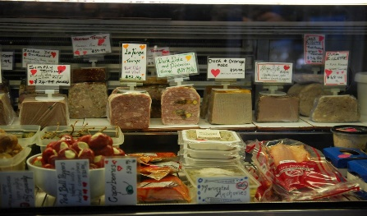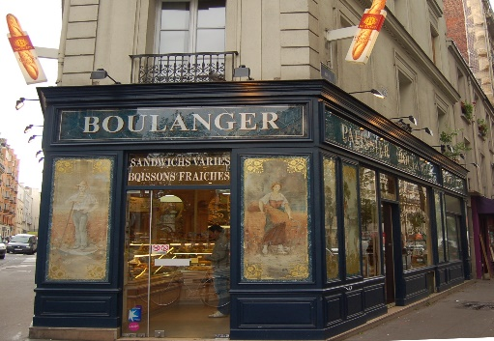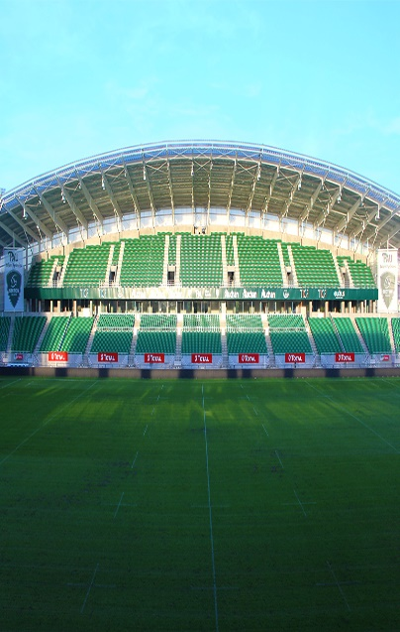

Summer Year 7 French Enrichment Homework

Design your own French town or village and write a description of it. This can be done on A4 or A3 paper or it can be done on powerpoint and uploaded to the folder “Year 7 French Enrichment Homework French Town” in Pupil Share.

Success Criteria

- Label as many places as you can in your town or village
- Write as if you live there and tell me that you live there
- Describe what there is
- Describe what there is not
- Give opinions of your town
- Use conjunctions to extend your sentences
- Use qualifiers with your opinion

