HEADTEACHER MESSAGE

Thank you to everyone who came to our Parents’ Meeting on Wednesday evening. It was fantastic to have such a great turn out. If you couldn’t make it and would like an update, please do get in touch. One of our parents, Mr Hamilton, has asked me to share his letter with you all; this has been sent out today for your information.

Today, the summer term’s enrichment curriculum began. We are really looking forward to seeing the children’s designs for a new wildlife haven. The Champions of Sport got off to a fine start with a cricket competition, under Mr Ramshaw’s expert guidance, whilst the wealth of talent in the huge drama group will certainly make casting parts an absolute pleasure for Miss Mason.

Have a lovely bank holiday weekend!

Kind regards,
Helen Samuels,
Acting Head teacher
______________________________________________________________________________________

LOOKING FOR SOMETHING TO DO TOGETHER THIS WEEKEND?

COMMUNITY NEWS AND EVENTS

 5th May 2018 - Spring Pantomine Workshop (Newcastle) FREE event. Do you like to write or to draw? Take part in fun workshops focusing on well-being - participants will create a pantomime from scratch! Workshop includes writing, set design and performing. 11.30am – 4.30pm. Book via launchpadncl@aol.com.

 6th May 2018 - BALTIC (Gateshead): FREE drop-in ART between 2pm – 4pm. Work with an artist, inspired by BALTIC’s current exhibitions, to try a new activity: you could be constructing giant sculptures, animating objects, drawing with light or making moves to music.

 7th May 2018 – Bill Quay Community Farm. (Gateshead) FREE entry. This annual May Day celebration will include a dog show, arts and crafts, meeting small animals, a Billy Quay's Got Talent event, face-painting, stalls and bake sale and tombola - all in aid of the farm. £2 to enter your pooch!

 7th May 2018 - Segedunum - Roman May Day Market: FREE for kids. Time: 10am – 5pm. The fort in Wallsend will be welcoming The Historical Combat Company who will be bringing history alive on a day featuring a Roman market and combat demonstrations. Visitors will be able to browse the market, witness gladiators doing battle, try their hand at archery or get involved in hands-on craft activities in historical tents.

Attendance this week – 94.4%


Thank you! We really appreciate all your efforts in getting to school on time, ready to start our day promptly.

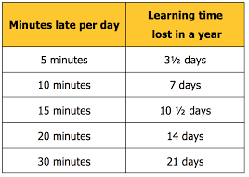

______________________________________________________________________________________

SCHOOL NEWS AND EVENTS

WELL DONE TO OUR HOUSE POINT HEROES OF THE WEEK!

KESTREL (168) | MERLIN (166) | OSPREY (158) | PEREGRINE (189)
Isaac (5A)  Katy C (5R)  Harlie (Y6)  Ryan & Kieran (Y7)  Josh (Y8) | Hannah (5A)  Zac (5R)  David (Y6)  Olivia (Y7)  Kacie (Y8) | Aidan (5A)  Max (5R)  Tom (Y6)  Philip (Y7)  Emily M (Y8) | Emily (5A)  Emma and Amy (5R)  Sam & Katy M (Y6)  Joseph (Y7)  Jemima (Y8)

 Our KS3 Sports Leaders attended Corbridge Tennis Tournament at the end of last week. We were delighted to hear that “Bellingham Sports Leaders did a great job keeping over 100 children organised considering they are only 12 or 13 years of age” from Sports Leadership Coach, Damien Dimmock. Great job, Sports Leaders!

 Charity News: Kacie, one of our Y8 pupils, has set herself the daunting challenge of keeping silent for a whole day of school. With the permission of her parents, Kacie will undertake a sponsored silence in aid of a local woman, Carrie, who is fundraising for her own life-saving surgery. We were impressed with the case Kacie made for being allowed to do this in school. Please let your child know whether or not you consent to them sponsoring her or not. There is obviously no obligation. Good luck, Kacie!

CLASS ZONE

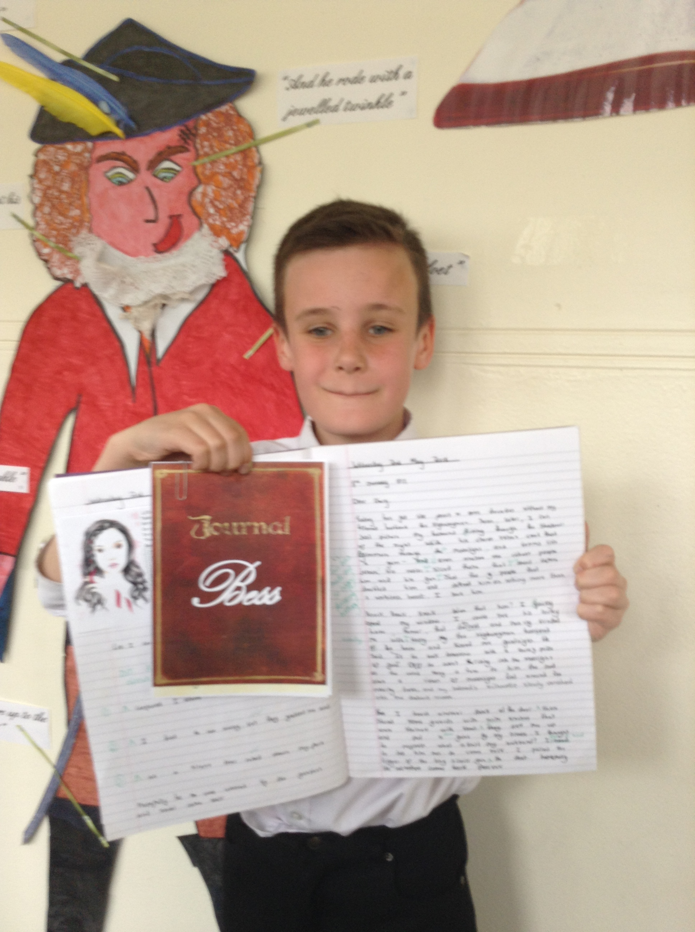
Our Year 5 pupils have excelled themselves in writing this week. They have been studying “The Highwayman” and writing their own diary entries as Bess. Miss Veitch was so impressed with their empathy for this character and with the careful language choices made by the children as they wrote in role.
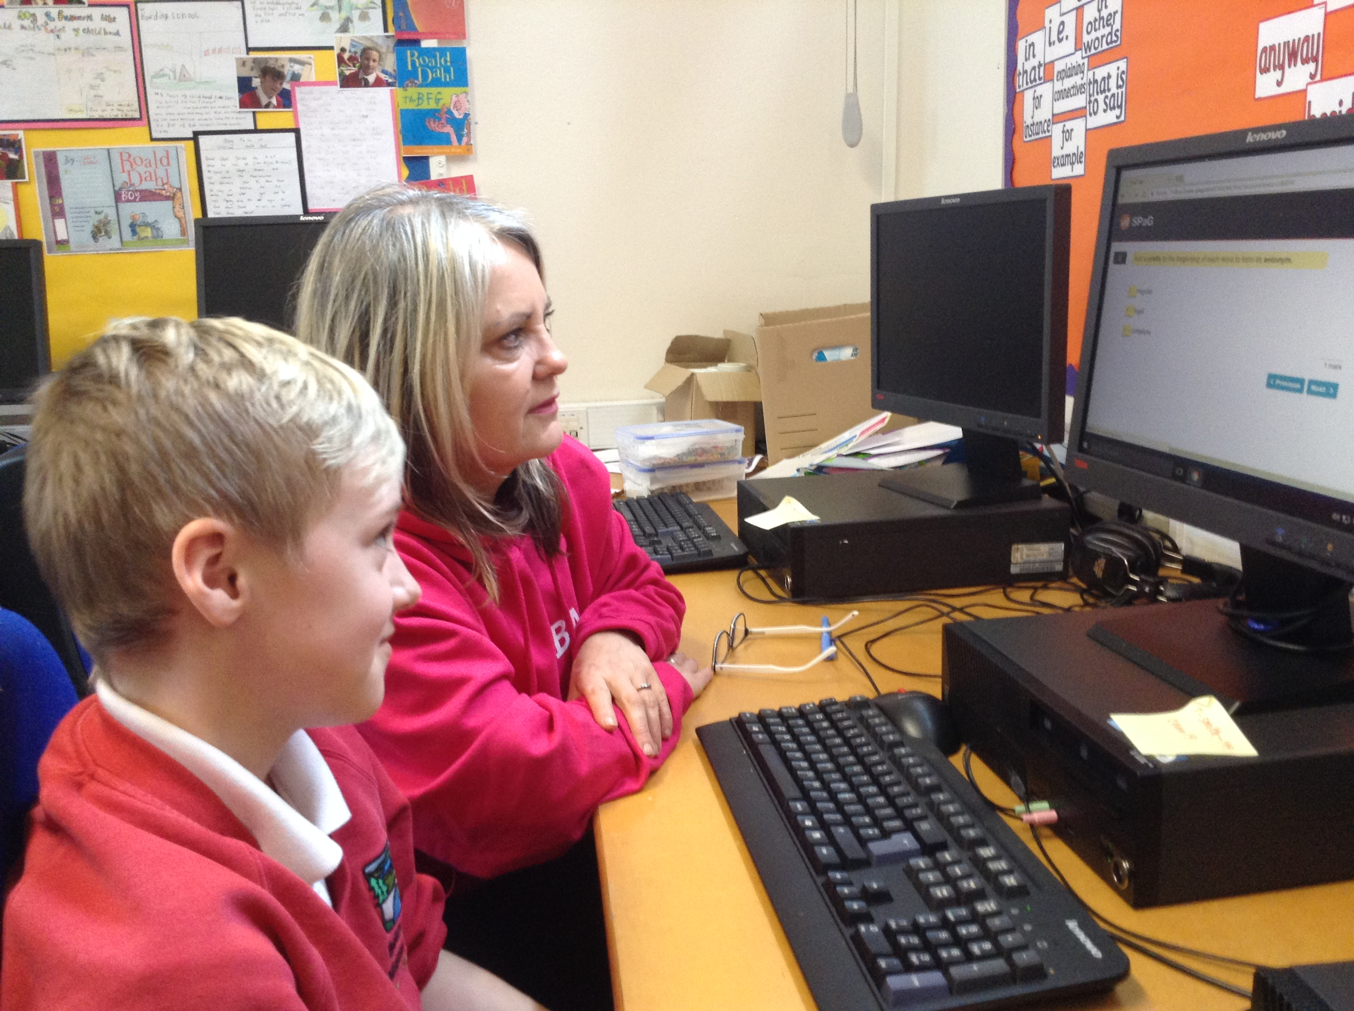
Y6 continue to impress everyone with their resilience and determination as SATs draw closer. In classwork, group work and individually, all of them are making us very proud. We think each and every one of them is amazing. Well done and keep going – nearly there now!

In history this week, Year 7 pupils have been learning about Mary, Queen of Scots, and the Babington plot, which planned to overthrow Queen Elizabeth I of England. Pupils were asked to try to break the code of a genuine message sent by Mary to her Catholic allies, replicating the work carried out by Sir Francis Wolsingham and William Davison in 1587. Bethany and Samantha were both successful in breaking the code and saving the Queen!
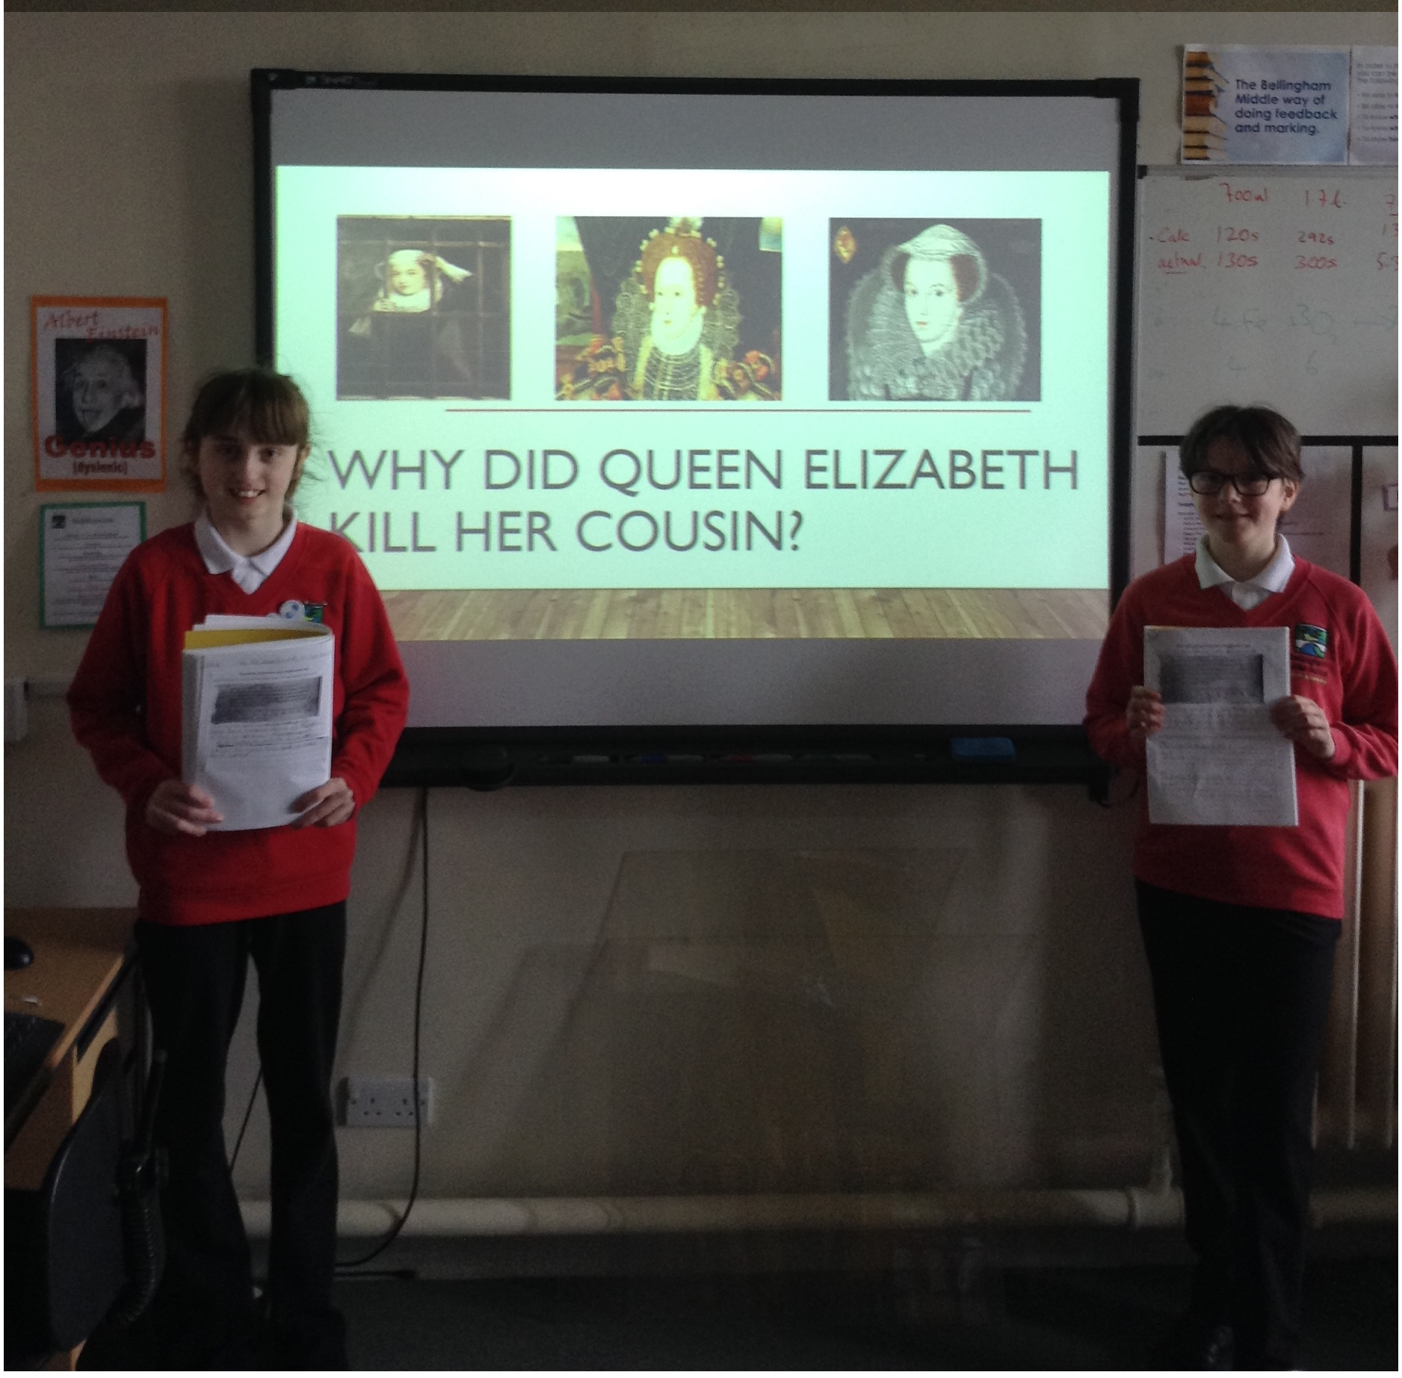
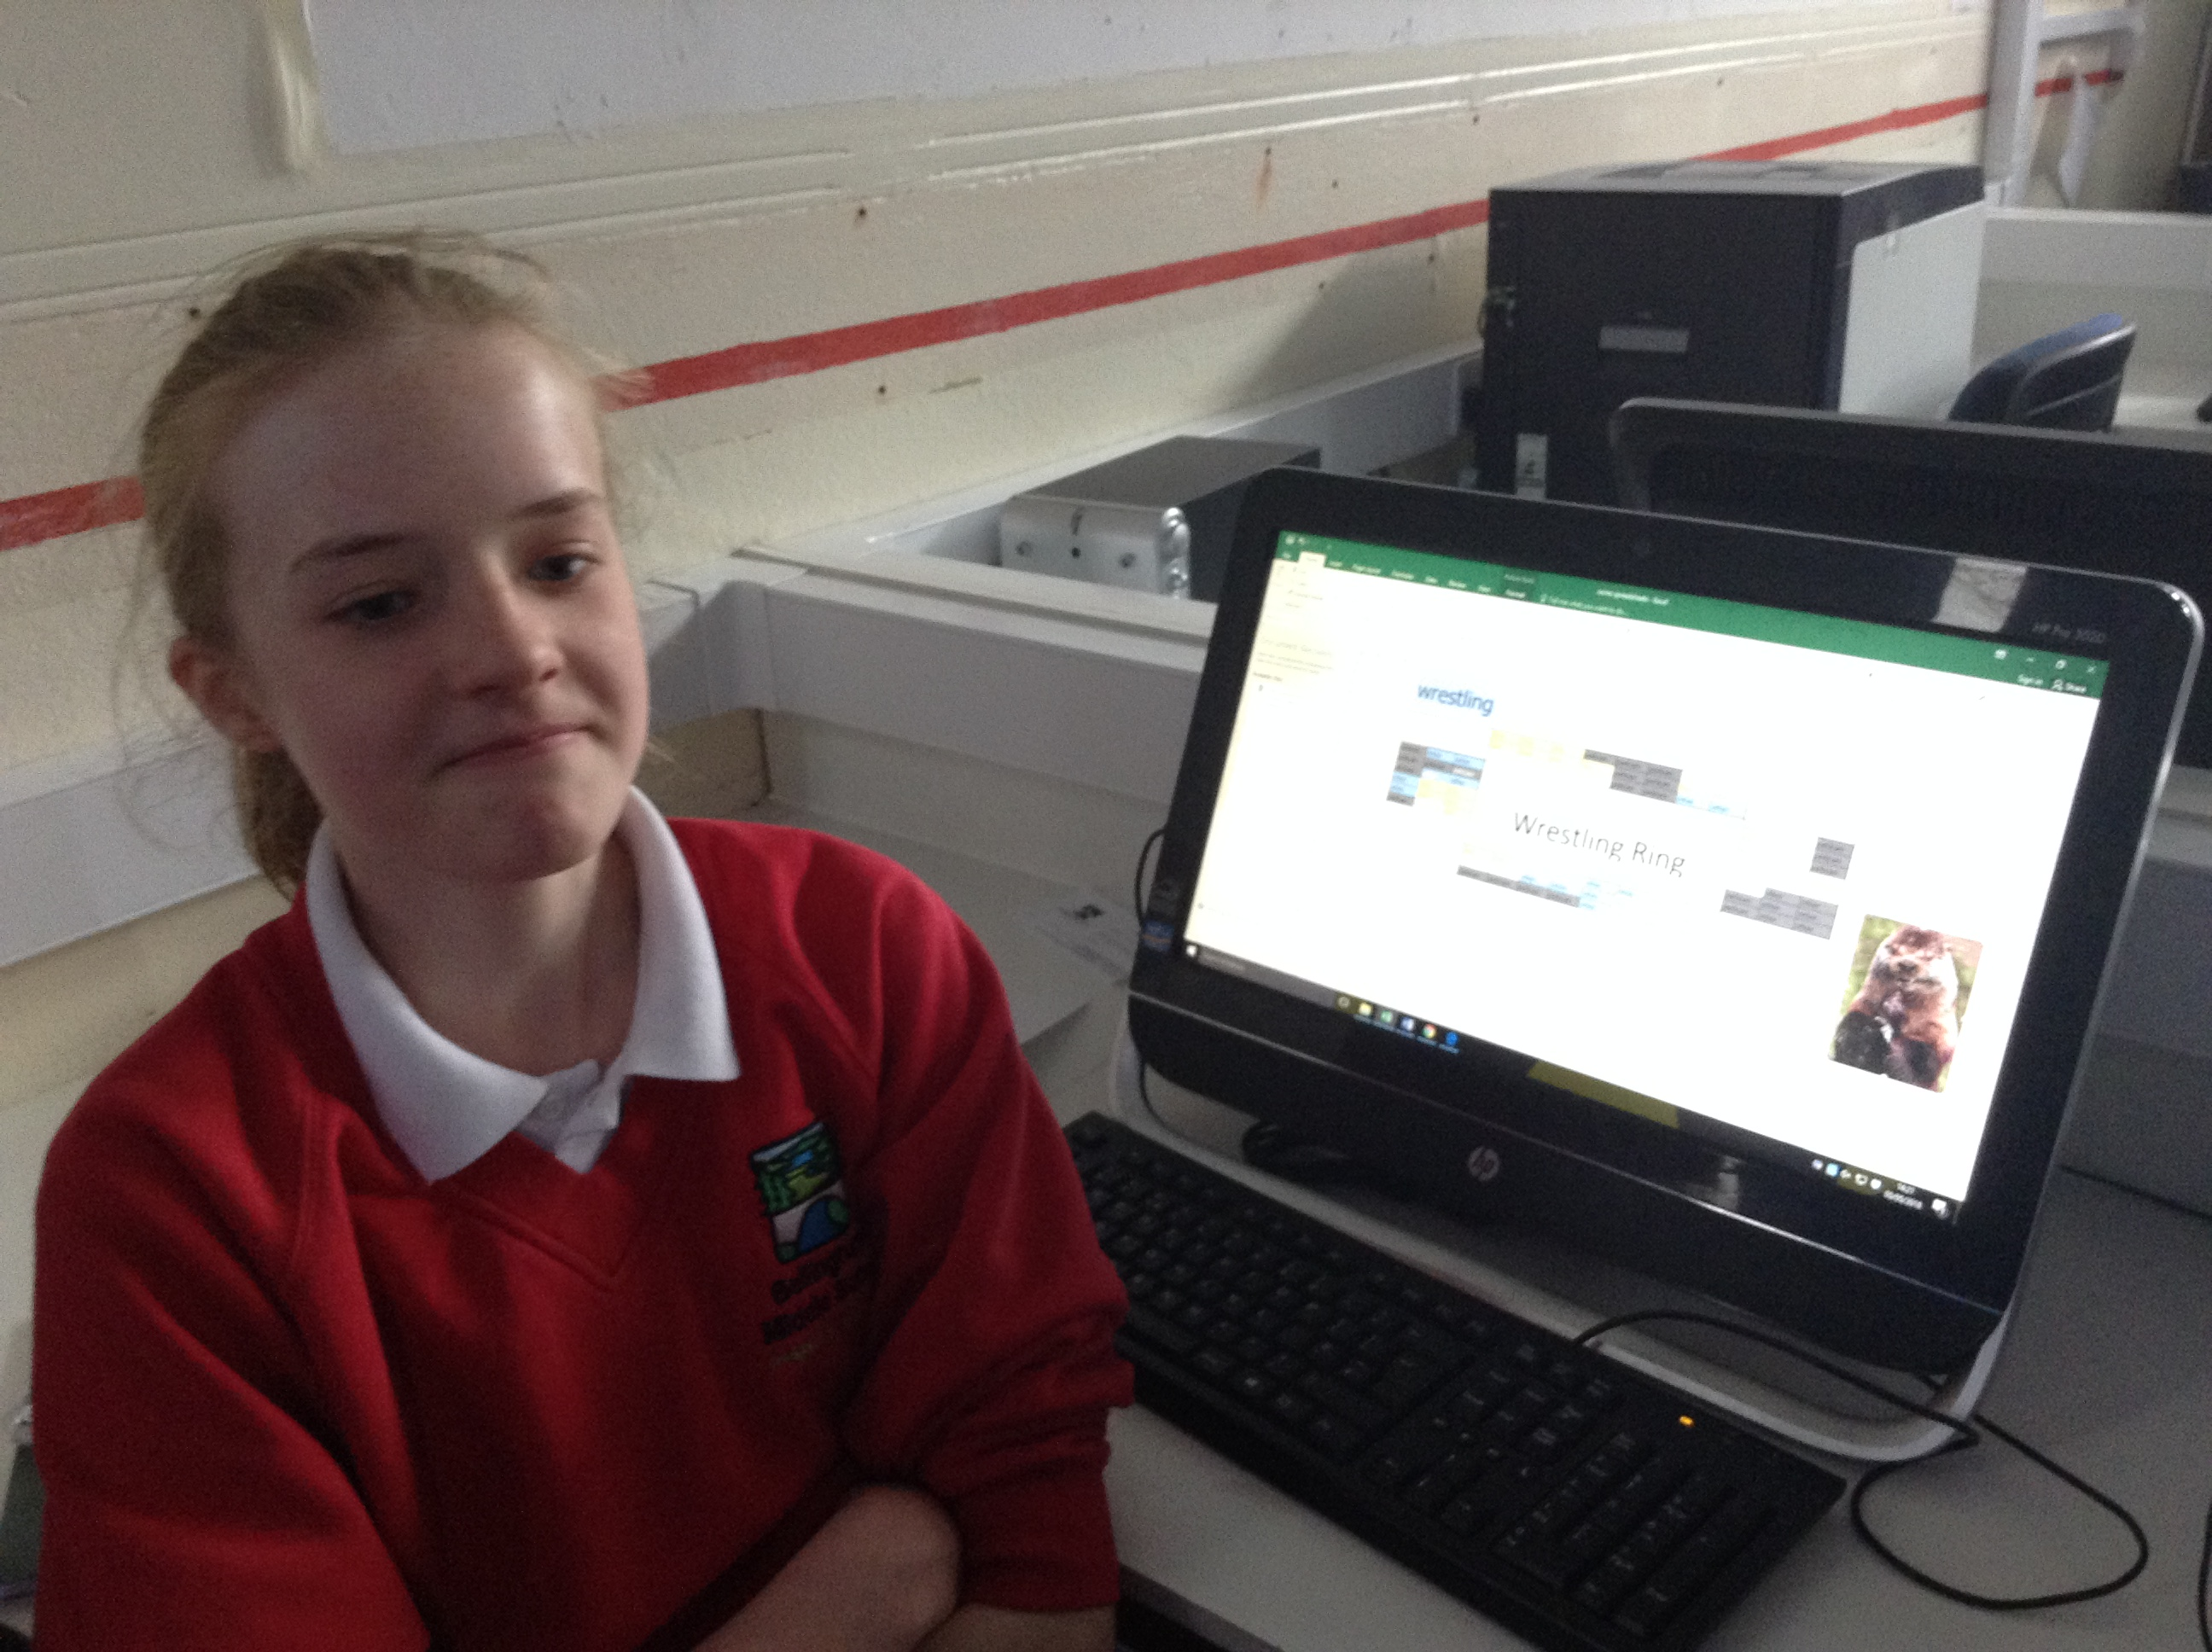
In computing this week, Year 8 has been working with spreadsheets. They have been setting up conditional formatting, using COUNTIF function as well as investigating how to use the AVERAGE, MIN and MAX functions and creating pie charts.

MEMOS AND REMINDERS
Summer Uniform: White polo shirt instead of white shirt and tie.
N.B. Any problems, please contact school. Gregg Sports have been in contact and are completing all orders already placed; these will be delivered to school. The office will collect the money on behalf of Greggs Sports, so any cheques should be made payable to Greggs Sports.
Stationery Shop Current Stock List
Black pen | 50p
Blue pen | 50p
Pencil | 30p
Rubber | 20p
Pencil sharpener | 20p

Contacting school if your child is ill: Could all parents please inform us by 9.15 am if your child is not able to attend school due to illness. You can leave a message on the answerphone if the line is busy or email: middleadmin@bellinghampartnership.uk
Dinner Money: Please could we ask for your help here? If you are sending money into school to pay for several days at a time, this needs to be in a named envelope. It would also be much appreciated if you could put your child’s name on the back of any payment by cheque. Thank you for your support.
:
FORTHCOMING EVENTS AND KEY DATES
Monday 7th May May Bank Holiday – school closed
Mon 14th – Thurs 17th May Y6 SATs Week – please ensure your child is in school.
Friday 18th May NF1 Awareness Day: wear blue and green to school
Monday 28th May Half term holiday week
Monday 4th June Back to school after half term
Thursday 7th June Area Athletics @ Wentworth Leisure Centre, Hexham
Friday 8th June KS3 Hawkhirst Trip
Tuesday 12th June Y5 Kielder Trip
Monday 18th June “Be Safe” workshops in school – all years
Wed 20th June - Fri 22nd KS2 Kingswood Trip
Sat 23rd June County Athletics @ Gateshead Stadium
Tuesday 17th July Summer Production at 6pm

