Year 6 Humanities Enrichment H/W Autumn 2

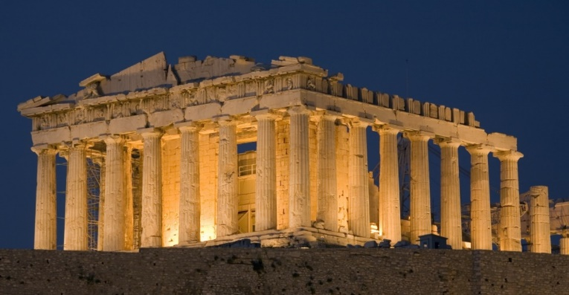
You need to choose at least one.
- Make a travel brochure about Ancient Greece. Where would you travel? Where would you stay? What could you do while you were there? Who would you recommend to visit? Use pictures with lots of facts and information.

- Write your own Greek myth

- Make a miniature Parthenon

Once finished put a copy of your work into your enrichment book and include a short evaluation about your project.

