Science Enrichment
Spring 2 Year: 5, 6, 7 and 8

Do you imagine yourself as the next major inventor of the 21st Century?
Can you invent something that will make the world a better place?
Here is a chance to come up with an idea that might just do that.
Take on the ‘Small is’ Challenge!
There are many more, but here are a few inventions from the last 50 years or so which have changed lives:
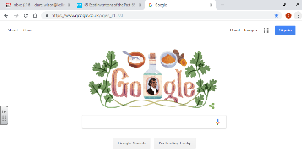
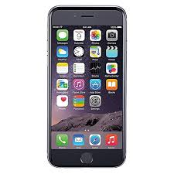
WWW.
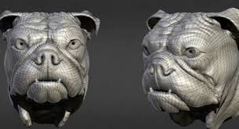 3d printing smart phone
CD
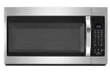
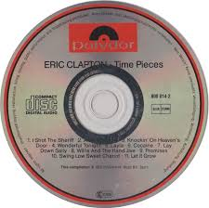
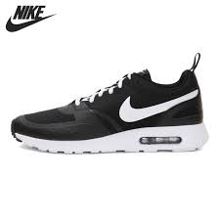Hi tech trainers
Microwave oven Solar cells

Simply Download the attached ‘Small is’ challenge sheets from the homework page and complete them by following the instructions.
On these pages; you will need to fill in a questionnaire; research a past invention and interview someone, who is at least 20 years older than you, about how technology has changed. All this, before you invent your own product - one that will help us lead more sustainable lives and make the world a better place to live.
Good luck and get inventing!
Due:

