HEADTEACHER MESSAGE

Welcome back everyone to the new school year at Bellingham Middle School. All pupils have returned to school refreshed, ready to learn and smartly turned out in their winter uniforms. Thank you for ensuring that your children are properly equipped for lessons. Do remember that our stationery shop runs during our free Wake-Up Club (breakfast included) on Mondays, Wednesdays and Fridays. Homework Club will also continue each lunch time for any pupils who need a quiet place or computer access to complete work. As ever, please do not hesitate to get in touch if you have questions or concerns about any aspect of school. We are here to listen and happy to help.

Our Y5 pupils have made a super start – read all about what they think in this week’s Pupil Zone. We would also like to extend a warm welcome to Elena and Jacob, who have relocated with their family to the area.

We would like to take this opportunity to provide the following update for you. As a school community, we care deeply about our school, its pupils and their families. We are looking forward to this year with your children. Our priority is giving them the best year ever. As you are aware, the governors have already exercised their right of appeal to the OSA and are awaiting the outcome. We understand from the OSA that there will be a public meeting at which parents and community members will be able to speak. Again, once we have more information about this, we will let you know.

Kind regards,
Helen Samuels,
Acting Headteacher
______________________________________________________________________________________

LOOKING FOR SOMETHING TO DO TOGETHER THIS WEEKEND?

COMMUNITY NEWS AND EVENTS

9th September 2018: Great North Run (FREE) Support the world’s biggest half-marathon in town this weekend, making sure you are there in time to enjoy the Red Arrows fly past, which is planned for 1.15pm. Good luck to all pupils (and siblings) who are taking part in the Mini Great North Run or the Junior Great North Run.


7th, 8th and 9th September 2018: Get North Water Sculpture. (FREE) Be wowed by the UK’s largest water sculpture which will perform hourly. Download three specially commissioned soundtracks and experience this impressive spectacle to three different pieces of music. The Water Sculpture is 80m long and reaches the height of the Tyne Bridge. Open daily between 10am and 11pm.

6th and 7th October 2018: Discovery Bricks Lego Show (Advance booking online essential). For Lego fans, this event promises to impress with the sheer range of construction on display. Discovery Centre, Newcastle


Attendance this week – 97.3%


Thank you! We really appreciate all your efforts in getting to school on time, ready to start our day promptly.

Did you know?
Attendance | Description | Approx. days lost per year | Approx. weeks lost per year
98 – 100% | Excellent | 0 to 4 | Less than 1
95 – 98% | Good | 5 to 9 | 1 to 2
93 – 95% | Satisfactory | 10 to 13 | 2 to 3
90 – 93% | Unsatisfactory | 14 to 19 | 4 to 6
>90% | Persistent Absence | More than 19 | More than 4

The government expects your child’s attendance to be 95% or better.
Schools are held to account for your child’s attendance.
Please remember holidays in term time will be unauthorised.
_______________________________________________________________________________

SCHOOL NEWS AND EVENTS


BMS London Trip 2019: We can’t wait for our exciting trip to the capital. For those who opted to use this payment method, the first instalment was due on 7th September. Thank you if you have already paid. Any late instalment payments need to be in by Monday 10th September please.
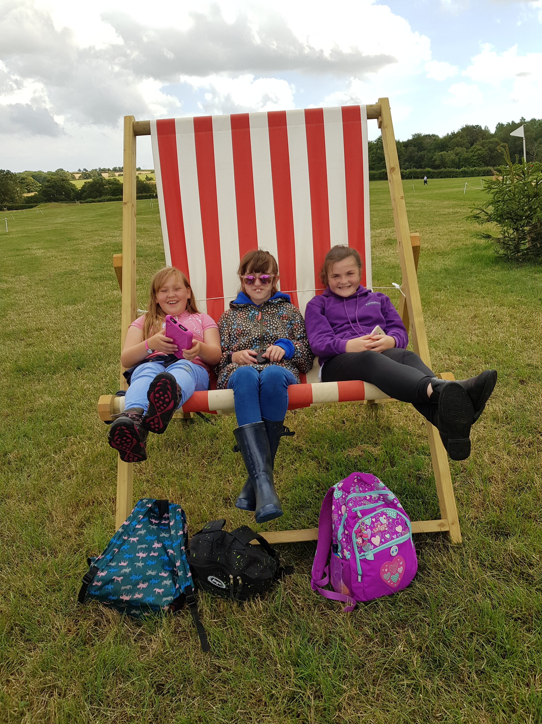
Pony Club: Bethany, Katie and Nina, who are all keen members of Bellingham Middle School’s Pony Club, enjoyed a wonderful trip to Burgham Horse Trials in the summer holidays. Thank you to Mrs Robinson for organising the trip and giving up her holiday to take the children.
Belsay Horse Trials: Congratulations must go to Erin (Y8) who won the Pony Club Team Showjumping as a member of South Northumberland Pony Club in the summer. Great job, Erin!


Staff News: Congratulations are also due to Miss Veitch, who got married over the summer holidays. She is now Mrs Robinson. We are also delighted to welcome Mrs Basing to the school staff and know that pupils are very much enjoying their new ADT lessons, getting creative with clay.

PUPIL ZONE
I have enjoyed playing in the playground and making new friends.
Being at middle school makes me feel grown up.
I have enjoyed making new friends and meeting new people. I also liked using clay in ADT – it got really wrinkly and cold.

Our new Y5 pupils have lots to tell you about their first week…

I am excited about getting harder work. I am looking forward to testing my ability to the limit.

I am excited about doing some experiments in the science lab and making a fruit salad.

I love middle school!

I have liked doing English with Mrs Robinson.
I have liked all of the food in the dinner hall. I am looking forward to sports day.

At school, my brother makes me welcome every day. I am so lucky that I have a brother like him.

I have enjoyed doing amazing PE lessons with Mr Ramshaw. I am excited about being in Food Technology and making fruit salad with Mrs Carr. I am looking forward to going on school trips.
I have enjoyed learning my way around and meeting new people. I am excited about learning new things and getting to know every one even better.
I have liked maths with Miss Mason.

I can’t wait for next week!

MEMOS AND REMINDERS

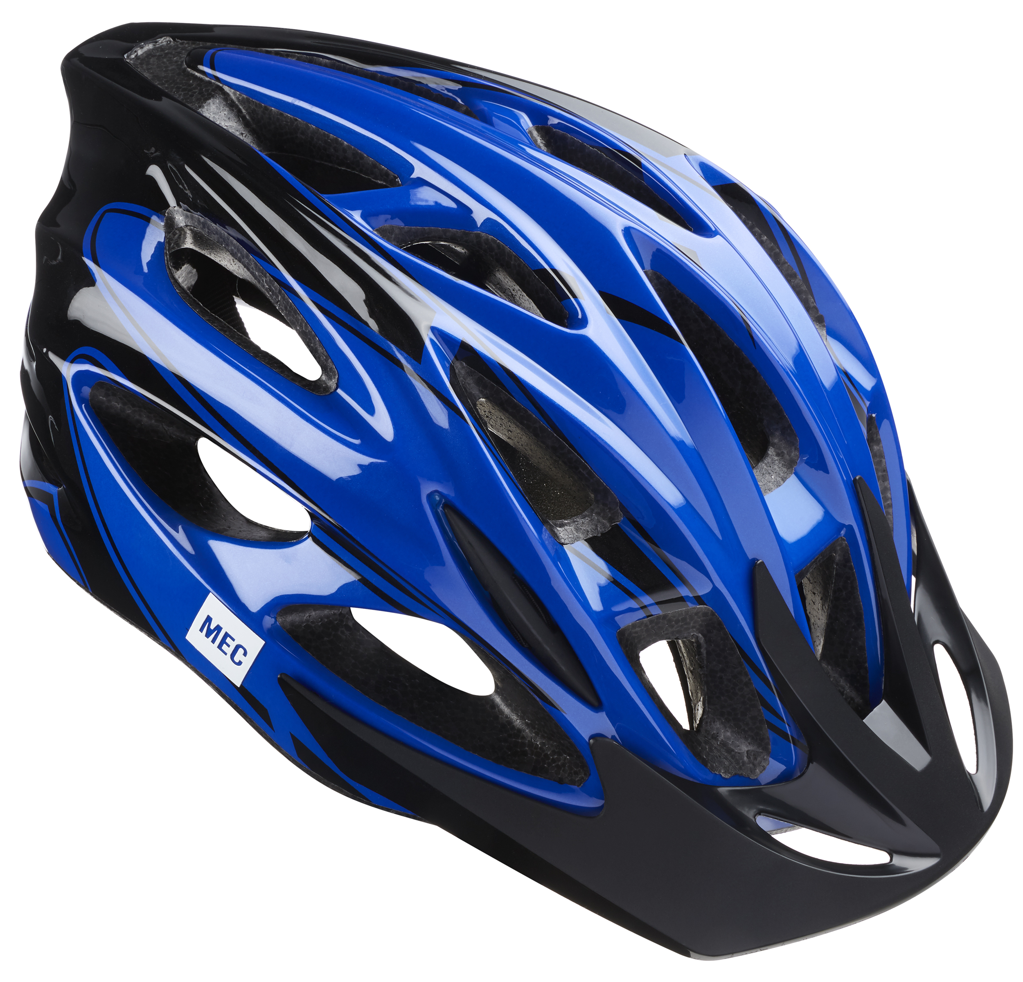 Bike Helmets: Your child must wear a bike helmet as he or she cycles to or from our school. We will let you know if we notice your child without a helmet and have to insist that he or she does not ride until one is worn. Please remind your child to stay safe on our roads by wearing a helmet. Further Bikeability training will be available next term.

Contacting school if your child is ill: Could all parents please inform us by 9.15 am if your child is not able to attend school due to illness. You can leave a message on the answerphone if the line is busy or email: middleadmin@bellinghampartnership.uk

Dinner Money: Please pay on the day or weekly from September. It is not possible to put credit on a tab. Whilst we would never see a child go hungry, we cannot afford to subsidise your child’s meal. If you require free school meals for your child, then please apply to Northumberland County Council. Call: 01670 623592 or apply online, using the link below. Thank you for your support.
https://online.northumberland.gov.uk/citizenportal/form.aspx?form=Free_School_Meals
:
FORTHCOMING EVENTS AND KEY DATES

Friday 7th Sept 1st instalment for London trip – pay by today
Mon 10th Sept HPV Y8 girls
Thurs 20th Sept School Photographer in
Tues 25th Sept British Army Visit - Resilience
Fri 28th Sept MacMillan Coffee & Cake Afternoon
Friday 5th Oct 2nd instalment for London trip – pay by today
Wed 10th Oct World Mental Health Day – “Hello Yellow”
Mon 15th Oct Democracy Week: KS3 Visit to County Hall
Fri 26th Oct Pupils attend school for last day of autumn first half term
Mon 5th Nov Teacher Training Day – no pupils
Tues 6th Nov Start of autumn second half term begins
Fri 16th Nov Children in Need Day
Fri 21st Dec End of autumn term

