Science Enrichment
Spring 1 Year: 5, 6, 7 and 8

Do you imagine yourself as the next best inventor of the 21st Century?
Can you make the world a better place?
Here is a chance to come up with your ideas.
Take on the ‘Small is’ Challenge!
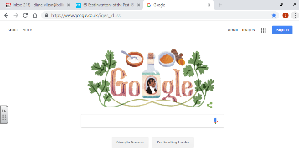
Here are a few inventions of the last 50 years which have changed lives

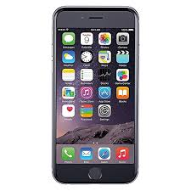
WWW.

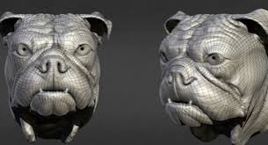 3d printing smart phone
CD
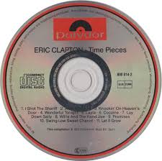
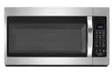
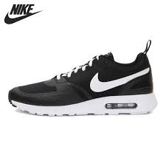Hi tech trainers

Microwave oven Solar cell

Simply Download the attached ‘Small is’ challenge pages and complete by following the instructions.
Due:

