HEADTEACHER MESSAGE:

We have had a fantastic start to our Careers’ Week today, with ten business ambassadors in school for the ‘Duck Production’, a manufacturing simulation. This experience was an introduction to the world of work for all of our pupils, who were organised into mixed age teams, chaired by Y8 leaders. We were impressed with the collaboration, initiative and innovation shown by pupils today and look forward to the rest of this special week.

London trip photographs are now organised into digital year group folders. These feature both sightseeing and social images the children have taken or requested, subject to the necessary consent. Please look out for the photo letter your child will bring home this week for further information.

Transition to high school is uppermost in the thoughts of many of our Y8 pupils. Pastoral leaders from Haydon Bridge High School, Queen Elizabeth High School and Ponteland High School have all now made visits to our school. We are in the process of organising extra visits for any pupils who may appreciate this. Please let us know if you feel your child would like extra time getting to know his or her new school, in addition to their transfer day. See dates.

On Thursday, many of our excellent athletes are due to travel to Wentworth Leisure Centre to compete at the Area Athletics Championships. We wish them well and hope that the rain stays away. All travel is within the usual school day therefore pupils will be back for their buses.

Finally, advance warning that our last week of the summer term is especially busy. Please look carefully at our dates for your diary, notably our school play night, which will be Tuesday 16th July.

Kind regards,
Helen Samuels,
Acting Headteacher
______________________________________________________________________________________

LOOKING FOR SOMETHING TO DO TOGETHER THIS WEEKEND?

COMMUNITY NEWS AND EVENTS


14th and 15th June – Sunsets and Serenades at Wallington: Make the most of the summer evenings by exploring the walled garden during late opening. Roll out a blanket, unpack a picnic and find the perfect spot to enjoy live music. Sunsets and Serenades

Every Friday and Saturday in June, enjoy the walled garden after hours where you can soak up the summer atmosphere, accompanied by live music. Bring a picnic or visit the Garden kiosk.Monday 27th May – Northumberland County Show: A fantastic day out: animals galore, fun for all the family and celebration of Northumberland. Open all day 9AM - 6PM. Free Parking. Come and make a day of it at Bywell Hall, Near Stocksfield. NE43 7AB County Show


July/August - Wild Northumbrian Tipis and Yurts: Rewild your week by joining one of our Bats and Pizza Nights at the tranquil, rural glamping site, beneath the starry blanket of the Northumberland International Dark Sky Park. Tarset Family Night

Upon arriving at the Pole Barn you will be greeted by Wild Intrigue guides Heather and Cain and introduced to others who are joining, where you can enjoy a hot or cold drink around the camp-fire. We will then get straight to creating delicious pizzas to cook in the amazing stone-baked pizza oven on site – what toppings will you choose? Plates emptied, we will take a short walk around the site to discover the crepuscular wildlife emerging with the setting sun.

Perhaps we’ll hear Tawny Owls calling, Roe Deer barking, the Blackbird’s bedtime melody. With the setting sun, we will return to the Pole Barn to enjoy toasted marshmallows and hot chocolate around the fire, listening to and chatting about all things wild. We will then set off to eavesdrop on fascinating, elusive creatures of the night; Bats!

Using specialist detectors, we will take you on a short Bat safari around Wild Northumbrian, where you will learn the different Bat species on site whilst learning what makes these little understood mammals just so intriguing. If you’re a family, choose one of our Family Nights, tailored to suit you and your little wild ones!

Attendance this week – 96.28%



Thank you! We really appreciate all your efforts in getting to school on time, ready to start our day promptly.

Did you know?

Every Day Counts! It is vital that pupils attend school, on time, every day in order to gain the greatest benefit from their education.

95% - 100% (less than 10 days absence in a year) is good attendance.
95% is the national average attendance rate for a child at primary school.

_______________________________________________________________________________

WELL DONE TO OUR HOUSE POINT HEROES OF THE WEEK!

KESTREL (134) | MERLIN (177) | OSPREY (115) | PEREGRINE (124)
Harry (Y5)  Katie (Y6)  Lucy (Y7)  Alex (Y8) | Cameron (Y5)  Callum (Y6)  Georgia (Y7)  Alicia (Y8) | Ebony (Y5)  Isla & Max (Y6)  Ruby & Tayah (Y7)  Hannah (Y8) | Shane (Y5)  Lucy C (Y6)  Pippa (Y7)  Paige (Y8)

KS2 River Study: Y5 and Y6 pupils enjoyed exploring how rivers shape our landscape and considering how humans impact on rivers during their recent trip to Gibside, which is part of the National Trust. The weather was kind and all our young geographers impressed NT staff with their excellent attitude to learning, critical thinking skills and responsible behaviour near water. Well done, KS2!

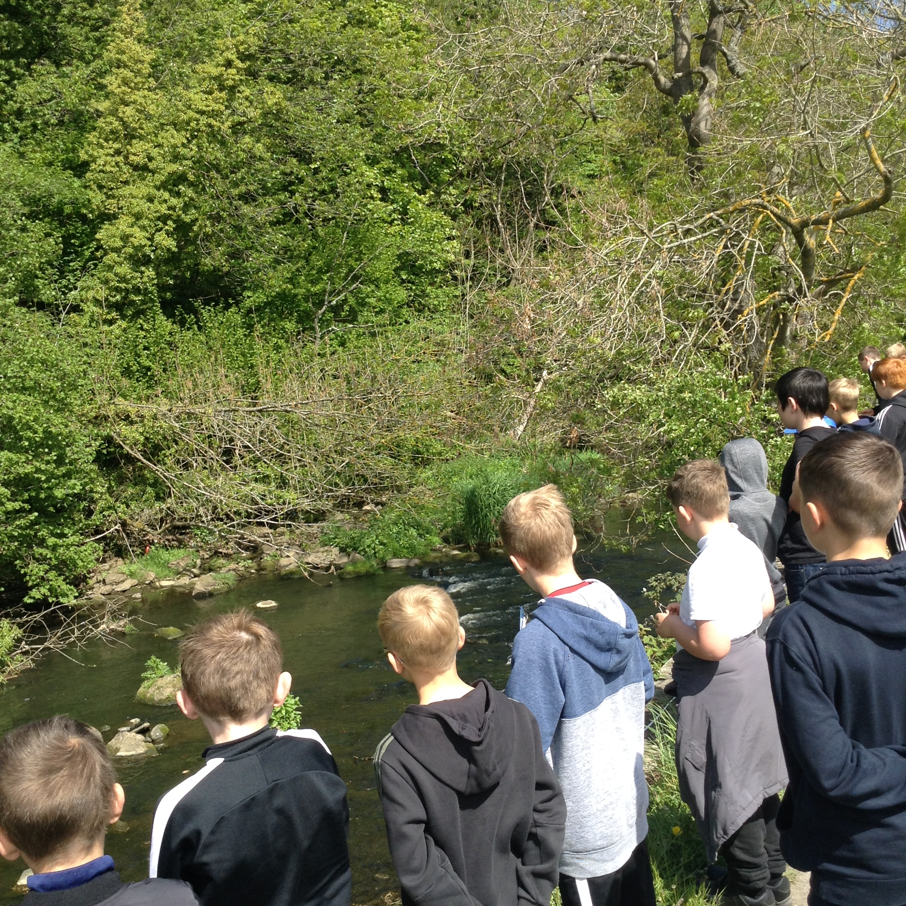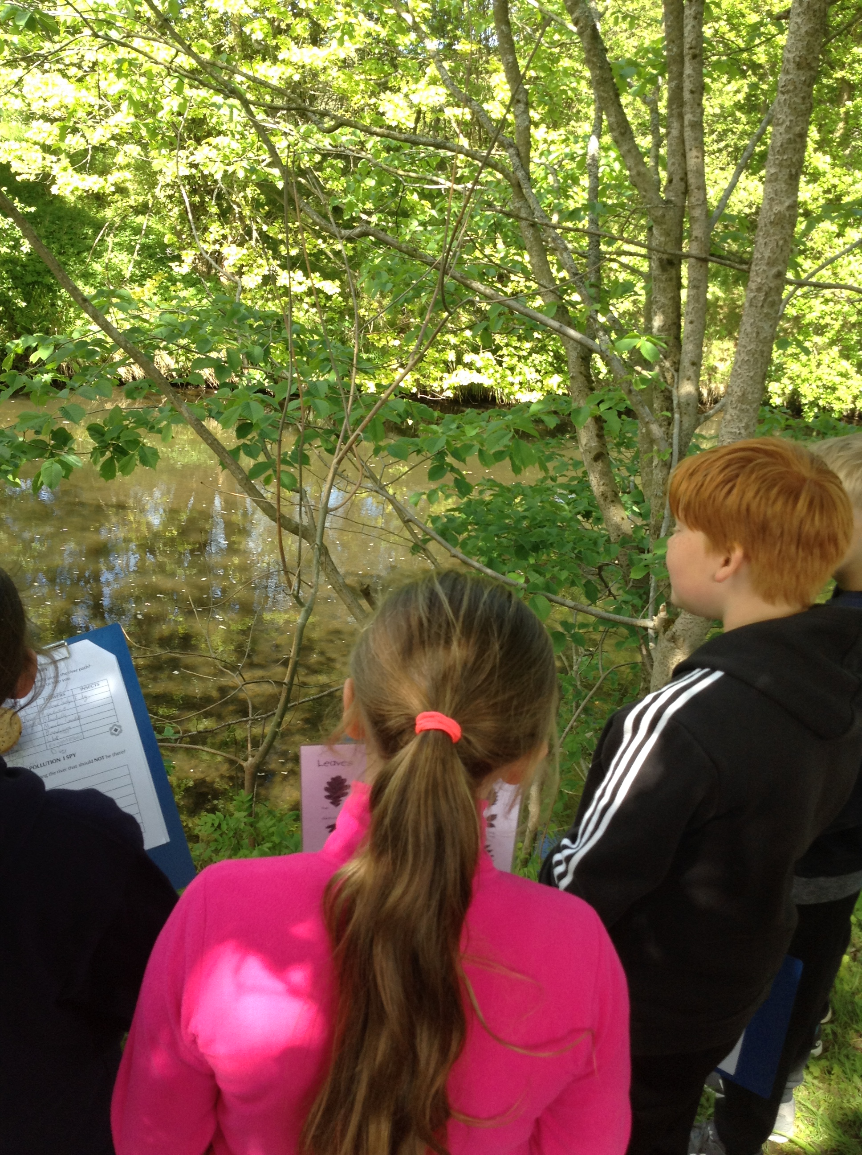

ADT Shakespeare Day: Pupils who took part in our Enrichment Challenge Week before half term surpassed themselves on their integrated ADT Shakespeare Day to produce stunning posters, which will be used for our school play at the end of term. Focused research into the context of a chosen Shakespeare play led to some wonderful creativity…
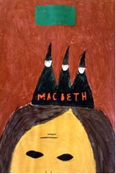
Enrichment Challenge Week Success
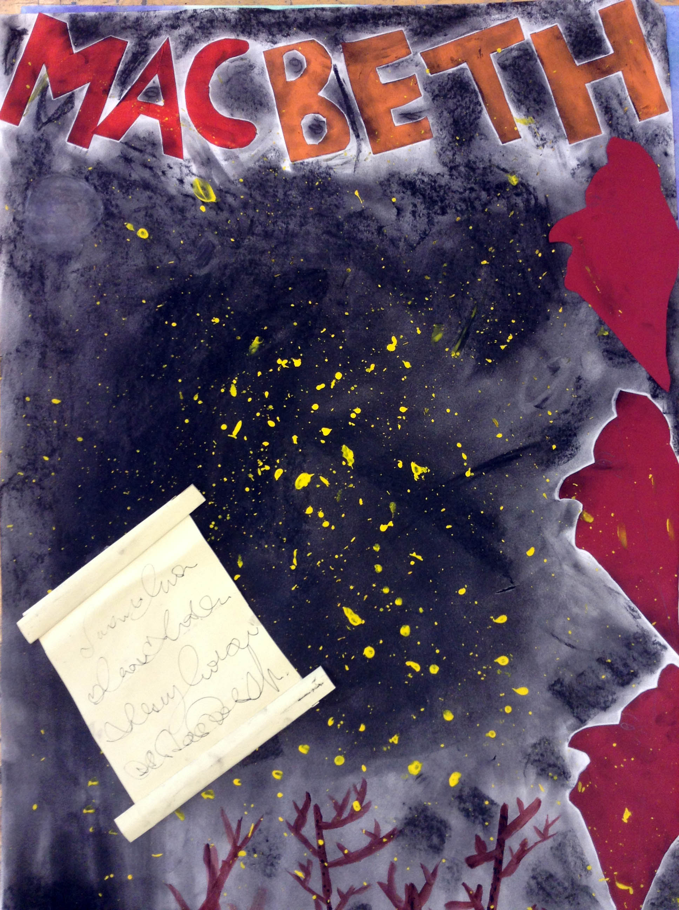

MEMOS AND REMINDERS
TROUSERS: Whilst we are proud of how smart the vast majority of pupils look, please could we remind parents/carers that tracksuit bottoms, black leggings and denim black jeans style trousers are not suitable for pupils to wear as school trousers.

 Bike Helmets: Your child must wear a bike helmet as he or she cycles to or from our school. We will let you know if we notice your child without a helmet and have to insist that he or she does not ride until one is worn. Please remind your child to stay safe on our roads by wearing a helmet.

Contacting school if your child is ill: Could all parents please inform us by 9.15 am if your child is not able to attend school due to illness. You can leave a message on the answerphone if the line is busy or email: middleadmin@bellinghampartnership.uk

Dinner Money: Please pay on the day or weekly on Mondays, using a named envelope. It is not possible to put credit on a tab. Whilst we would never see a child go hungry, we cannot afford to subsidise your child’s meal. If you require free school meals for your child, then please apply to Northumberland County Council. Call: 01670 623592 or apply online, using the link below. Thank you for your support.
Apply for Free School Meals
:
FORTHCOMING EVENTS AND KEY DATES

Mon 10th June BMS Careers Week
Mon 10th June Introduction to the World of Work Day: Duck Production
Fri 14th June Y6 NDAS Specialist PSHCE Workshop 1
Wed 19th June Author Visit
Friday 21st June Y6 NDAS Specialist PSHCE Workshop 2
Thurs 27th June Kids’ Lit Quiz Trip: Teams competing at Corbridge Middle
Fri 28th June Be Safe Day: PSHCE Workshops for all years
Thurs 4th July Transfer Day
Fri 5th July Sports Day
Tues 16th July Summer Production: Shakespeare Rocks
Wed 17th July Whole School Reward Trip: South Shields
Thurs 18th July Prom Night
Fri 19th July Y8 Leavers’ Trip & Leavers’ Celebration Assembly

