Y8 Humanities Enrichment Project - Chinese Art and Culture Summer 2
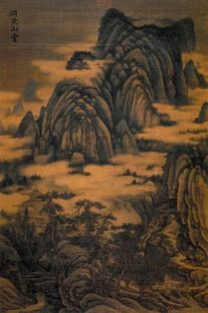
Ancient China produced and inspired many types of beautiful works of art. Different eras and dynasties had their specialties. Chinese philosophy and religion had an impact on artistic styles and subjects.
Mountain Hall by Dong Yuan
Landscape Painting from Five Dynasties Period
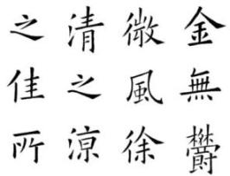
The Three Perfections were calligraphy, poetry, and painting. Often they would be combined together in art.
Calligraphy - This is art of handwriting. The Ancient Chinese considered writing an important form of art. Calligraphers would practice for years to learn to write perfectly, but with style. Each of the over 40,000 characters needed to be drawn precisely. In addition, each stroke in a character had to be drawn in a specific order.
Calligraphy

Poetry - Poetry was an important form of art as well. Great poets were famous throughout the empire, but all educated people were expected to write poetry. During the Tang Dynasty poetry became so important that writing poetry was part of the examinations to become a civil servant and work for the government.

Painting - Painting was often inspired by poetry and combined with calligraphy. Many paintings were landscapes that featured mountains, homes, birds, trees, and water.
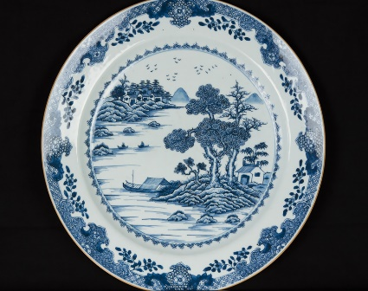
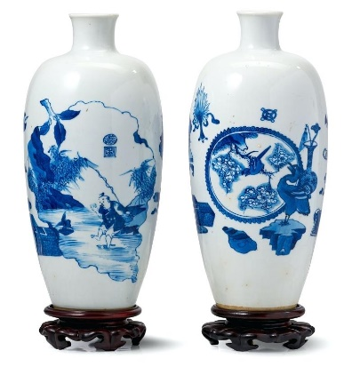
Porcelain
Fine Chinese porcelain was not only an important art, but also became an important export. During the Ming Dynasty blue and white vases became highly prized and were sold to the wealthy throughout Europe and Asia.
Task - To research and then create a piece of Chinese art which clearly reflects ancient Chinese culture. You may use any materials to create one of the above suggestions, or you could research and make one of your own. You must give some background information (no more than 100 words) on the origins of the type of art you have chosen to produce. You will also need to write a brief evaluation (about 100 words too) of the process you went through to create your piece of art. If you are unable to complete or stick the project in your enrichment book, you should include a photograph of your project and stick in it.

