HEADTEACHER MESSAGE:

We have had an exceptionally busy and successful week at school, with all pupils rising to the challenge of either the residential trip to London or the Enrichment Challenge Week. A huge well done to all pupils for their excellent behaviour, enthusiasm and obvious enjoyment of these opportunities. Many, many thanks are due to the dedicated staff team who have given up their time to ensure all pupils had a memorable week. We are also very grateful to all those parents/carers who made the later pick up time last night – much appreciated.

Due to the late return from London last night, our special edition bulletin celebrating this week’s activities and excursions will be sent to you after half term, once we have had a chance to sort and collate the many photographs from the ipads used. These will also be made available for you, subject to the necessary consent, after the holiday.

Parts have now been allocated for our summer play, “Shakespeare Rocks”. Please support your child by helping them to learn their lines and song words for after half term. We are looking forward beginning rehearsals on our stage after half-term. It is still possible for your child to be involved in the play as well as continuing with his or her enrichment option. Please encourage them to let Mrs Samuels know if this is the case.

We continue to look for support of our Careers Week in June. If you, or anyone you know, could spare an hour or two to talk to small groups of pupils about their work during this week, then please get in touch with us as soon as possible.

Have a wonderful half-term holiday! We return to school on Monday 3rd June.

Kind regards,
Helen Samuels,
Acting Headteacher
______________________________________________________________________________________

LOOKING FOR SOMETHING TO DO TOGETHER THIS WEEKEND?

COMMUNITY NEWS AND EVENTS


Monday 27th May – Northumberland County Show: A fantastic day out: animals galore, fun for all the family and celebration of Northumberland. Open all day 9AM - 6PM. Free Parking. Come and make a day of it at Bywell Hall, Near Stocksfield. NE43 7AB County Show


30th May - Digital Discovery Event for 9-14 year olds: An exciting opportunity to see a range of different technologies in use, with three STEM workshops. Lunch provided. Adult must accompany child. Location: The Fuse Media Centre, Prudhoe. £7 booking fee to secure space. Digital Discovery Day

Attendance this week – 96.28%



Thank you! We really appreciate all your efforts in getting to school on time, ready to start our day promptly.

Did you know?

The school day has two attendance sessions.

If your child seems unwell in the morning but seems better by lunchtime, please bring them into school for the afternoon session.

This will help to keep your child’s attendance as high as possible

_______________________________________________________________________________

LONDON PREVIEW SELECTION

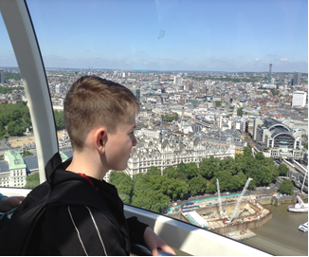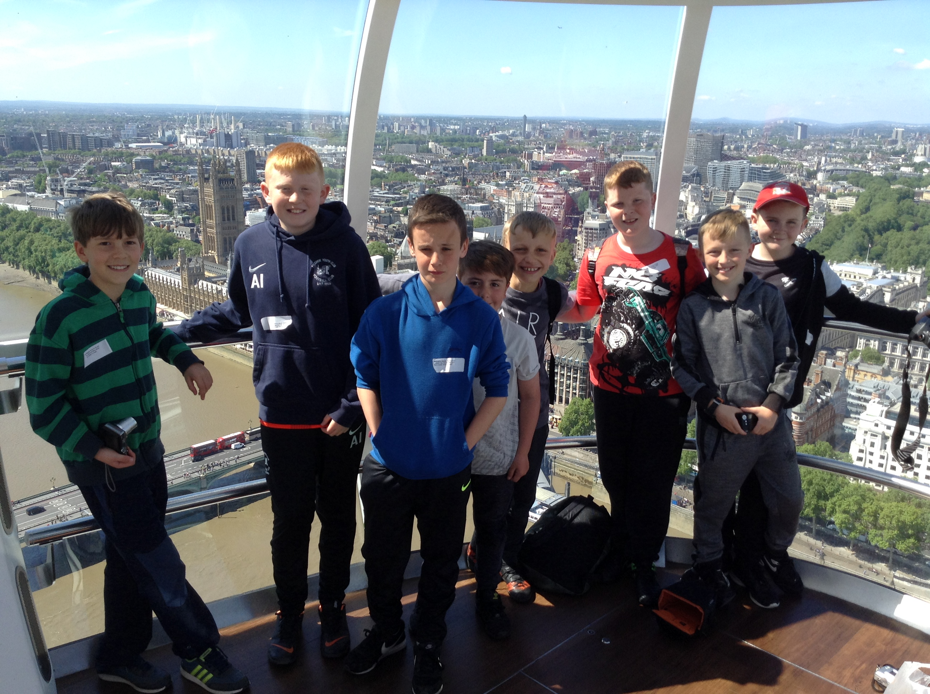
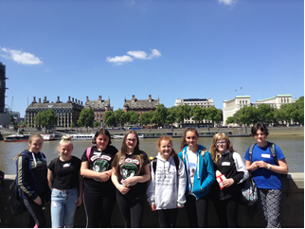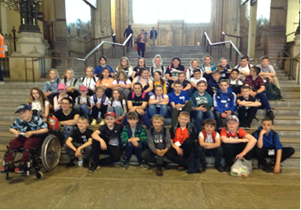

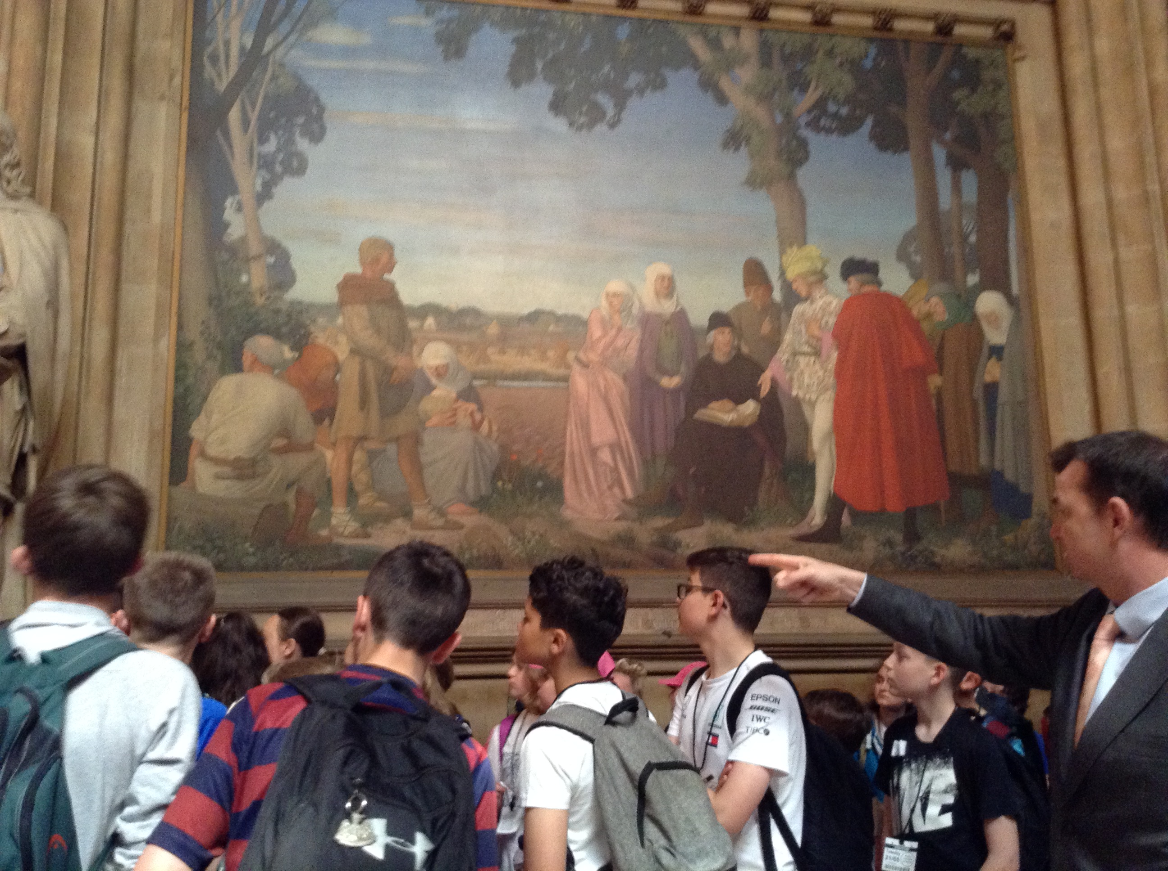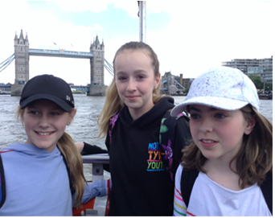
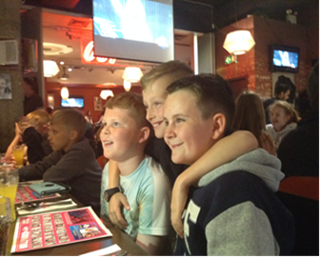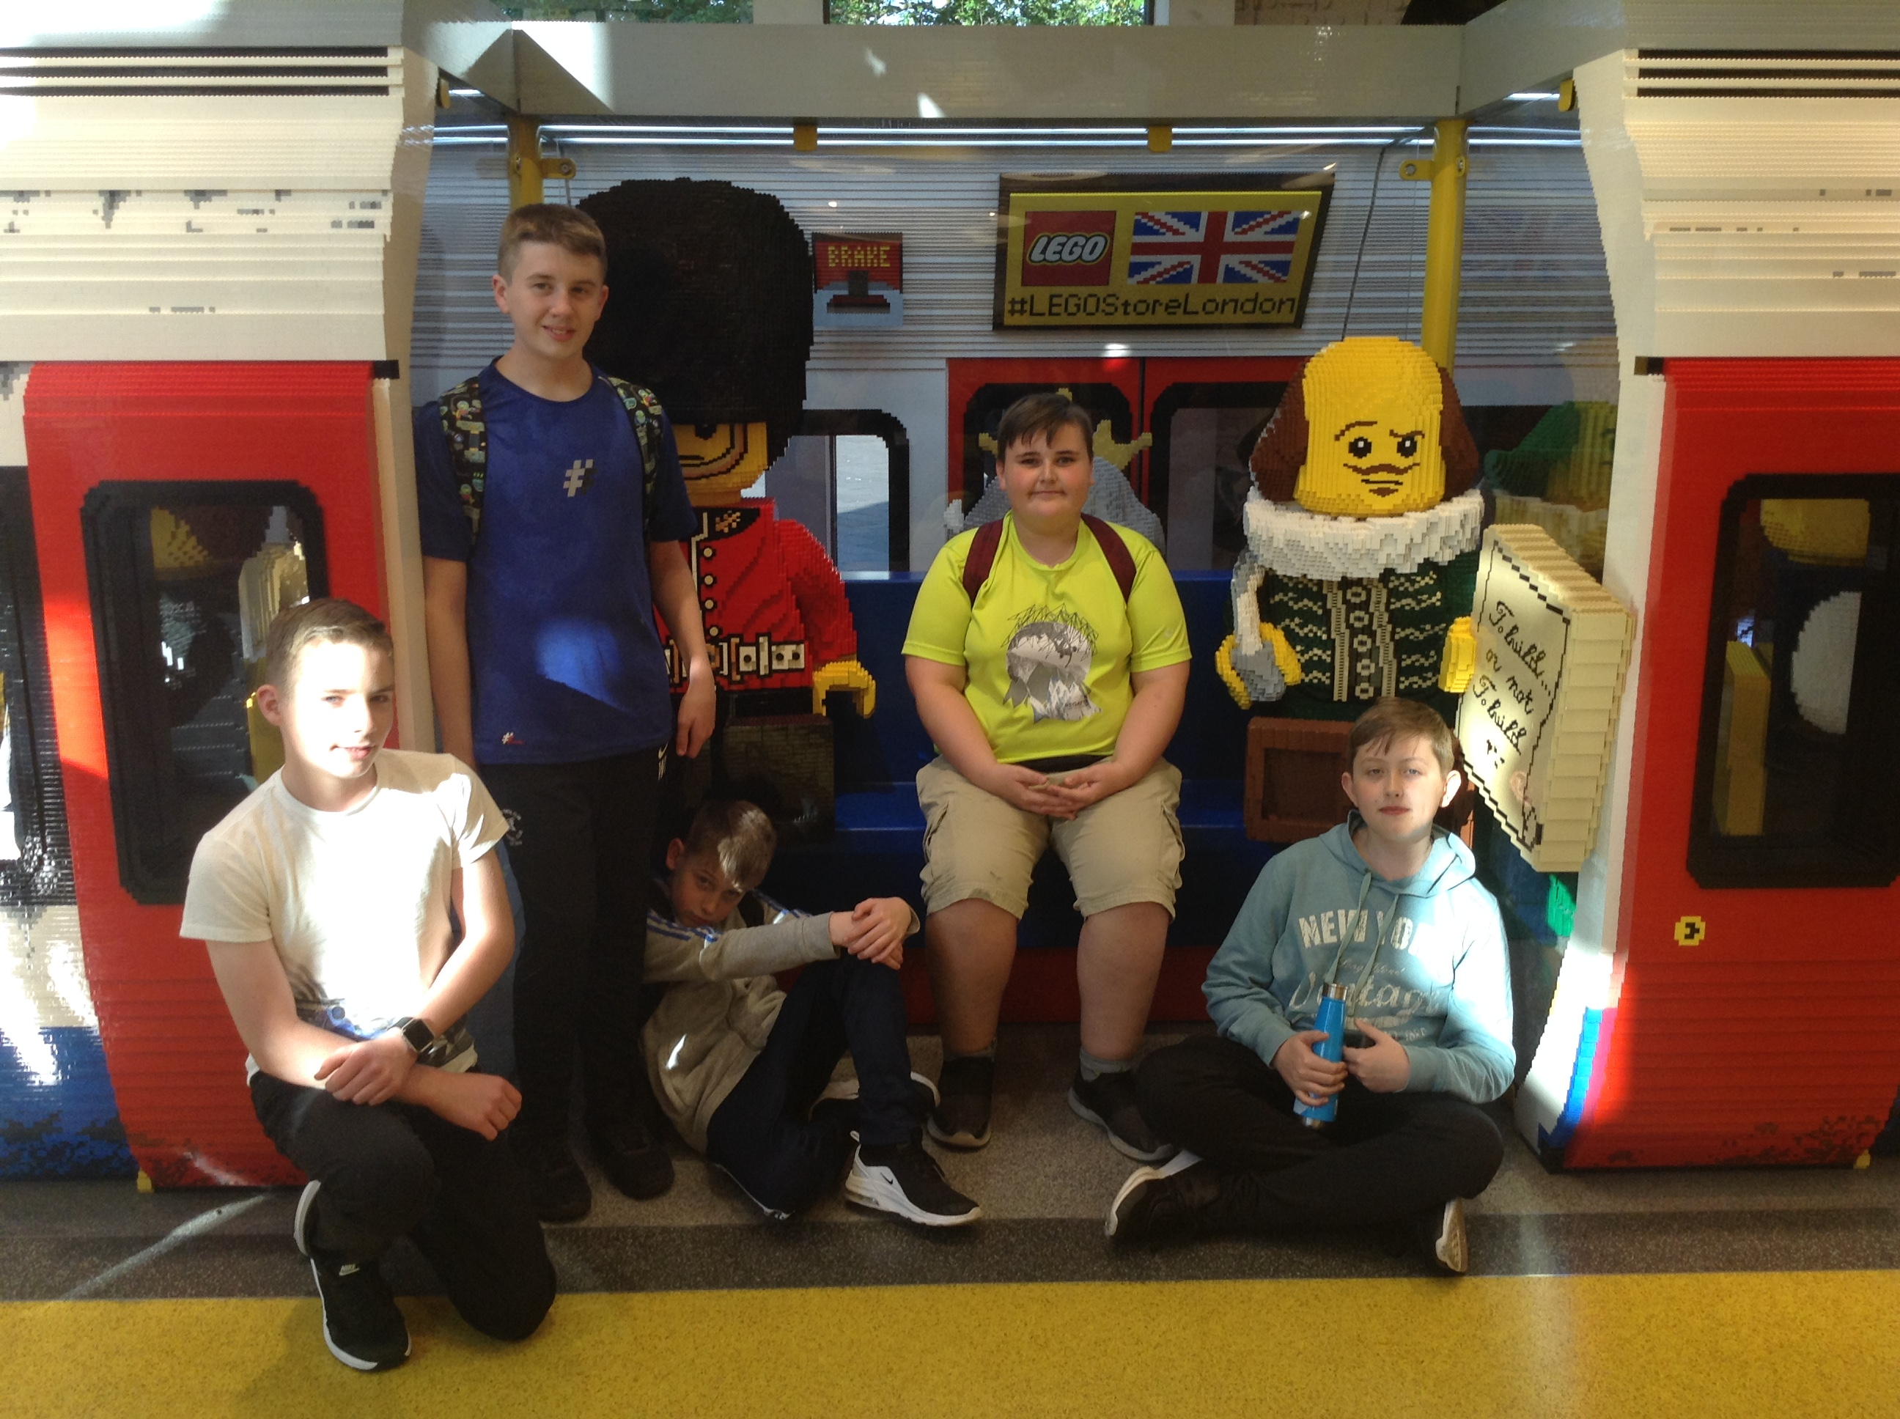
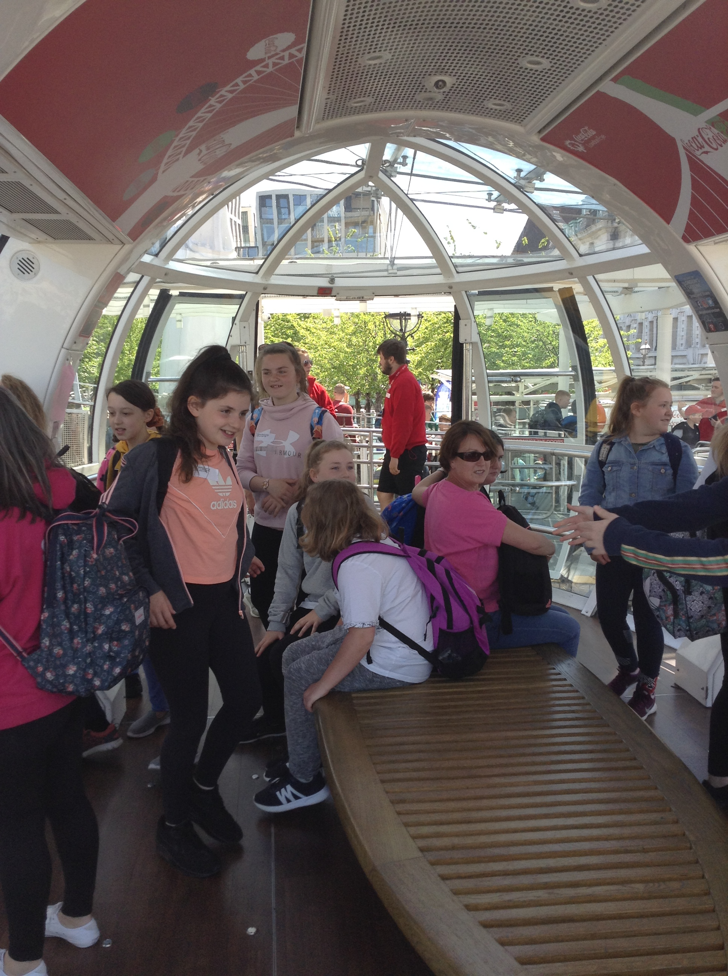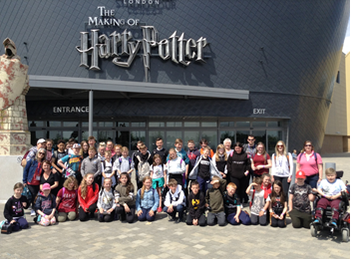

MEMOS AND REMINDERS
TROUSERS: Whilst we are proud of how smart the vast majority of pupils look, please could we remind parents/carers that tracksuit bottoms, black leggings and demin black jeans style trousers are not suitable for pupils to wear as school trousers.

 Bike Helmets: Your child must wear a bike helmet as he or she cycles to or from our school. We will let you know if we notice your child without a helmet and have to insist that he or she does not ride until one is worn. Please remind your child to stay safe on our roads by wearing a helmet.

Contacting school if your child is ill: Could all parents please inform us by 9.15 am if your child is not able to attend school due to illness. You can leave a message on the answerphone if the line is busy or email: middleadmin@bellinghampartnership.uk

Dinner Money: Please pay on the day or weekly on Mondays, using a named envelope. It is not possible to put credit on a tab. Whilst we would never see a child go hungry, we cannot afford to subsidise your child’s meal. If you require free school meals for your child, then please apply to Northumberland County Council. Call: 01670 623592 or apply online, using the link below. Thank you for your support.
Apply for Free School Meals
:
FORTHCOMING EVENTS AND KEY DATES

Mon 27th-Fri 31st May Half Term
Mon 3rd June Pupils return to school
Mon 10th June BMS Careers Week
Mon 10th June Introduction to the World of Work Day: Duck Production
Fri 14th June Y6 NDAS Specialist PSHCE Workshop 1
Wed 19th June Author Visit
Friday 21st June Y6 NDAS Specialist PSHCE Workshop 2
Thurs 27th June Kids’ Lit Quiz Trip: Teams competing at Corbridge Middle
Fri 28th June Be Safe Day: PSHCE Workshops for all years
Thurs 4th July Transfer Day
Fri 5th July Sports Day
 Happy Holidays! 

