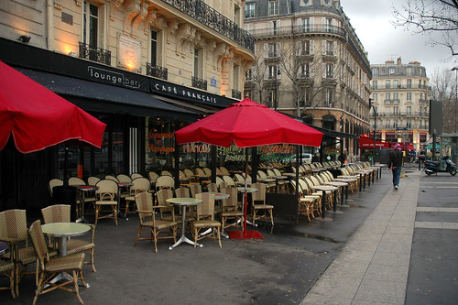

Y5 French Enrichment Homework

Design and illustrate a menu for a French café, and write a short role play to go with it.

Success Criteria:
- Include drinks
- Include breaksfast foods
- Include lunch foods
- Check to see that you have the correct gender for each word
- The role play should include a waiter/waitress and customer

