Y8 Geography Enrichment Homework
Is fracking for shale gas a good idea?

There is still an increasing demand for energy in the UK. One suggestion is that we can use fracking to collect shale gas which is a fossil fuel. Fracking is the process of drilling down into the earth before a high pressure water mixture is directed at the rock to release the gas inside. Water, sand and chemicals are injected into the rock at high pressure which allows the gas to flow out to the head of the well. It is a controversial technique. The BBC Website has further information: http://www.bbc.co.uk/news/uk-14432401 . You can also find your own additional information.
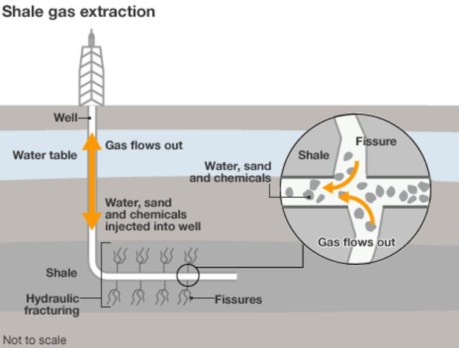
Your task is to write a letter to Peter Jackson, the Head of Northumberland County Council, because they are considering giving planning permission for a fracking test drilling site in the county. You must state if you are for, or against, fracking in Northumberland. You need to justify your reasons with geographical and scientific facts.
Expectations – you should include:
- A typed or neatly written formal letter of at least 2 paragraphs using persuasive language
- A statement if you are for, or against fracking
- Reasons behind your decision
- Challenge: To really impress you could include 2-3 references of where you found evidence to support your decision.

Deadline: The homework is due in of December and should take you at least 2 hours.
Make sure you put on name on your work.

